Catching the Perfect SAR Waves: Mathematical Model

Instructions: Use the table and graph provided to record your results when calibrating your radar system. Represent the distance as a function of voltage. It is recommended that you verify your voltage output more than once to ensure accurate readings. Readings from sensor to sensor may vary slightly.

Radar Position: Horizontal
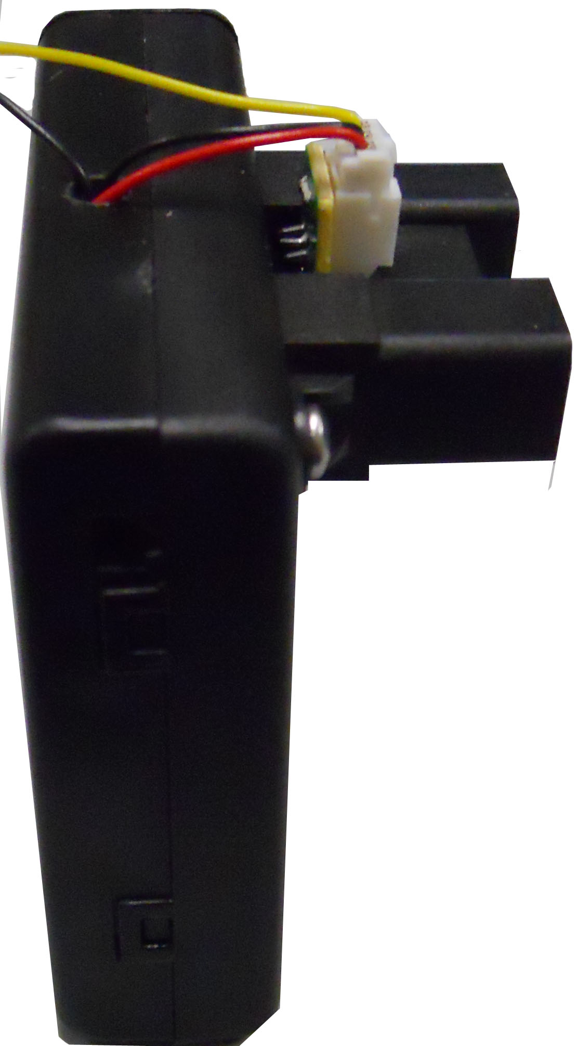

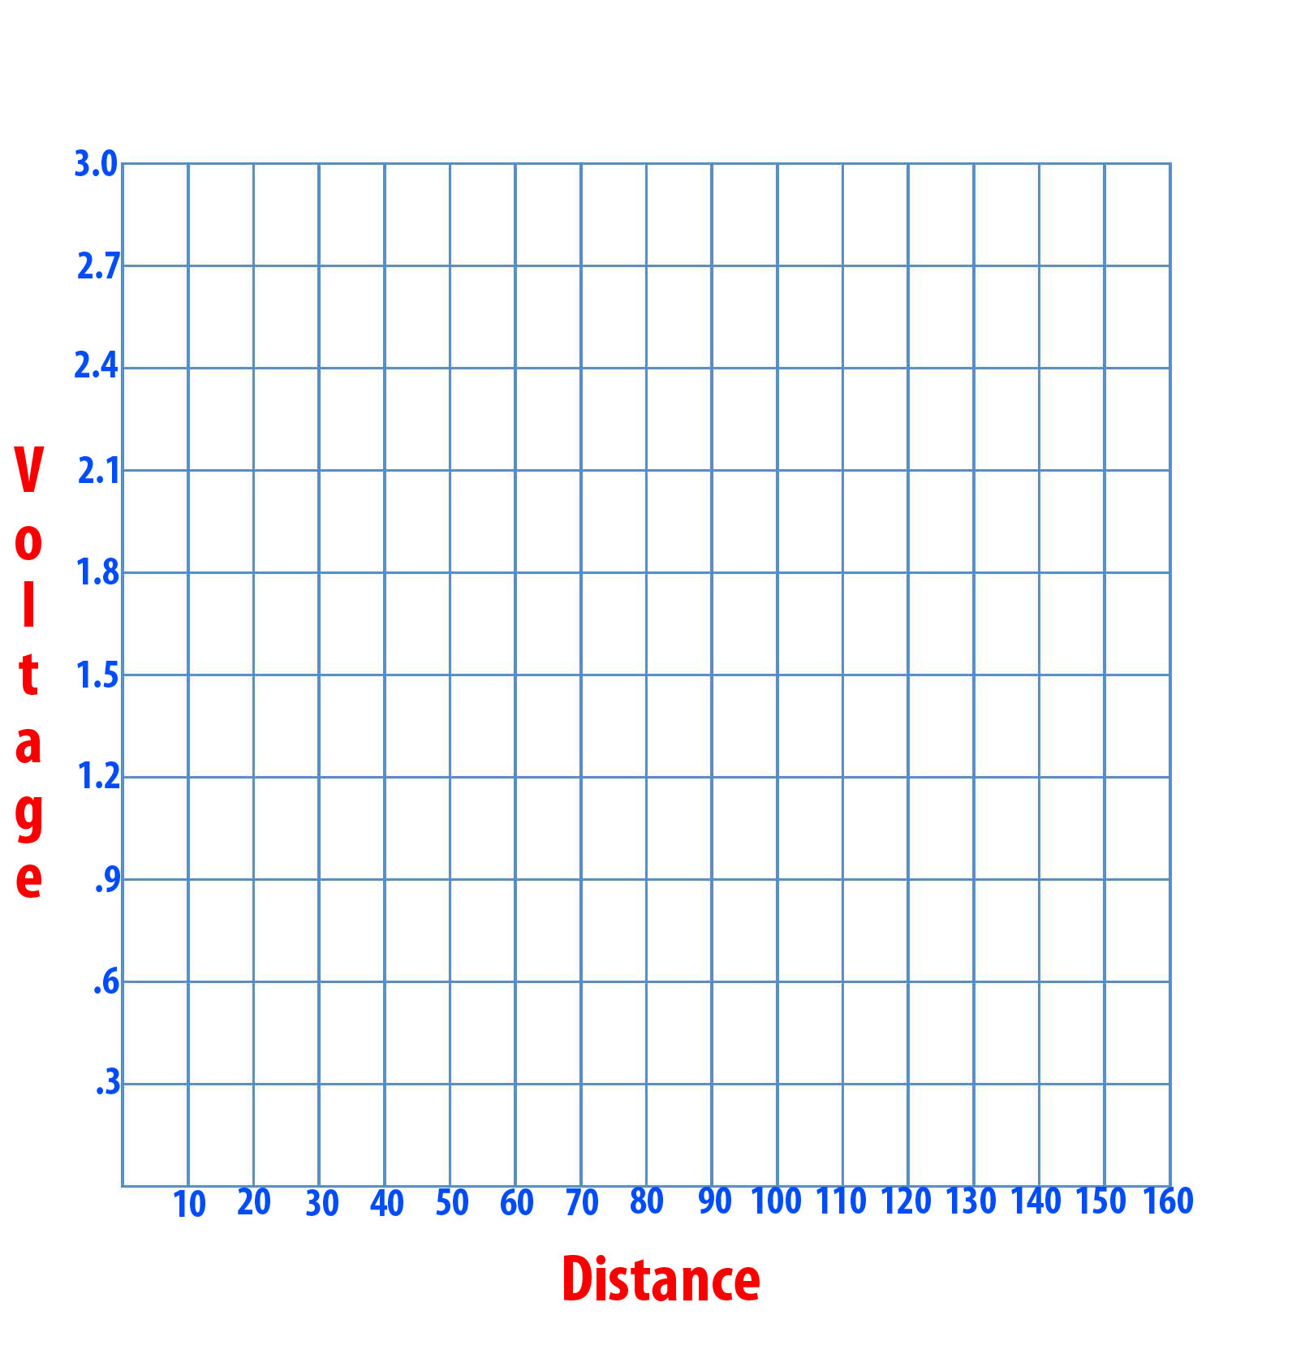

Distance (cm) | Voltage  (V)

Radar Position: Vertical
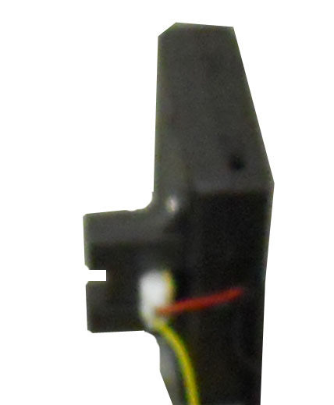

Distance (cm) | Voltage  (V)

