Catching the Perfect SAR Waves: Mathematical Model
ANSWER KEY
Instructions: Use the table and graph provided to record your results when calibrating your radar system. Represent the distance as a function of voltage. It is recommended that you verify your voltage output more than once to ensure accurate readings. Readings from sensor to sensor may vary slightly.

Radar Position: Horizontal
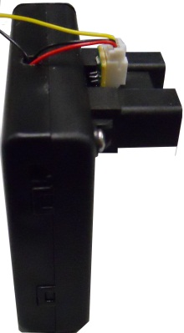

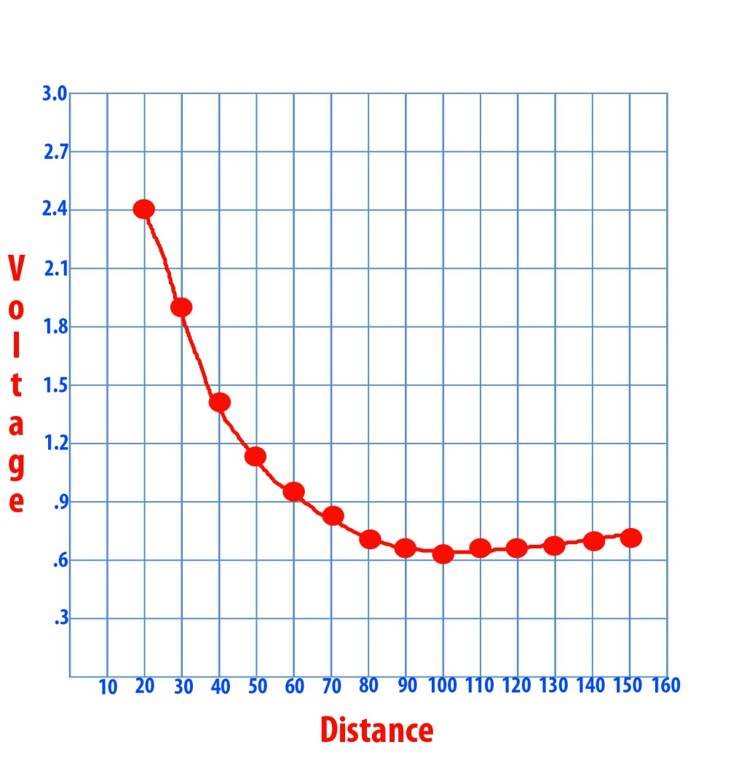

Distance (cm) | Voltage  (V)
20 | 2.40
30 | 1.90
40 | 1.45
50 | 1.15
60 | 0.98
70 | 0.86
80 | 0.79
90 | 0.75
100 | 0.73
110 | 0.75
120 | 0.75
130 | 0.77
140 | 0.78
150 | 0.79

Radar Position: Vertical
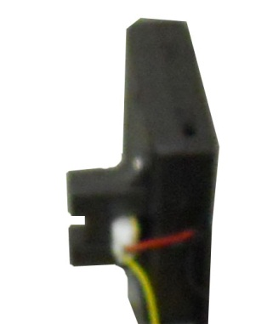

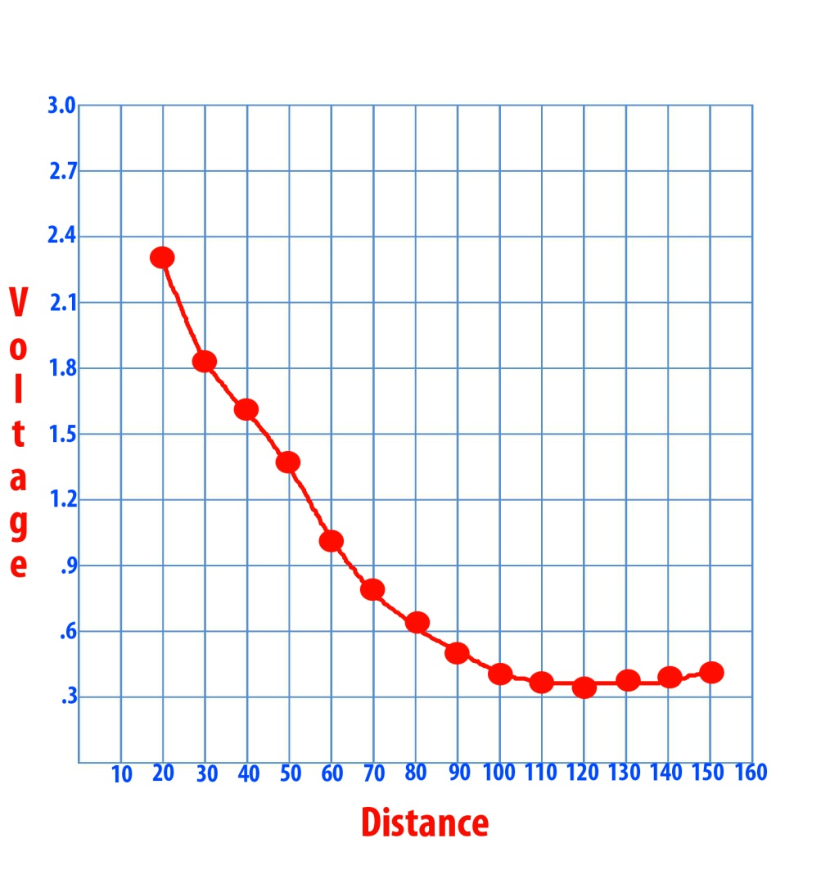

Distance (cm) | Voltage  (V)
20 | 2.37
30 | 1.85
40 | 1.62
50 | 1.43
60 | 1.02
70 | 0.81
80 | 0.66
90 | 0.54
100 | 0.45
110 | 0.40
120 | 0.39
130 | 0.41
140 | 0.43
150 | 0.47

