Sensors and Scatterplots Activity –
Excel® Worksheet

Directions
Using our class datasheets, we will analyze additional scatterplots, using Microsoft Excel® to make those plots.
To get started, please launch the Excel program, and follow the steps described below.
Scatterplot Questions
- Is there a relationship between BMI and pulse rate? (Follow the steps below to find the answer.)
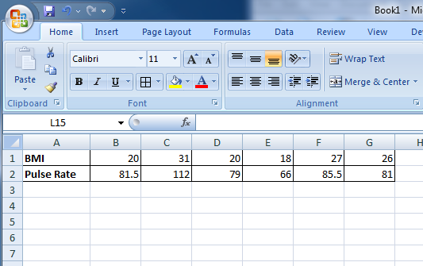
STEP 1: Enter Data
- Type ‘BMI’ in Cell A1.
- Type ‘Pulse Rate’ in Cell A2.
- Enter all BMI values from your class data sheet in Row 1.
- Enter the pulse rate values from your class data sheet in Row 2.

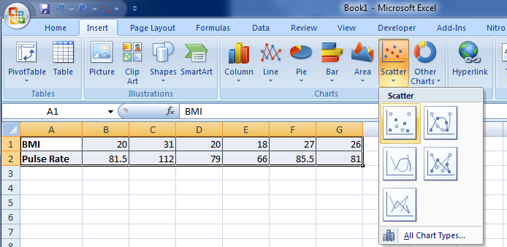
STEP 2: Create Scatterplot
- Select the data in both rows.
- Select Insert from the top menu and then Scatter from the Charts submenu.
- Select and click on Scatter with Only Markers option.

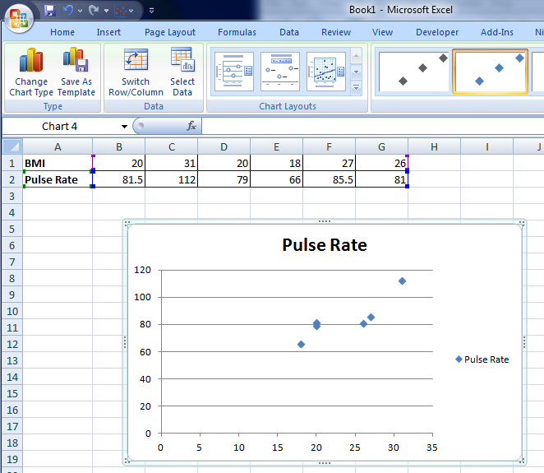
A scatterplot as shown to the right below will be generated.

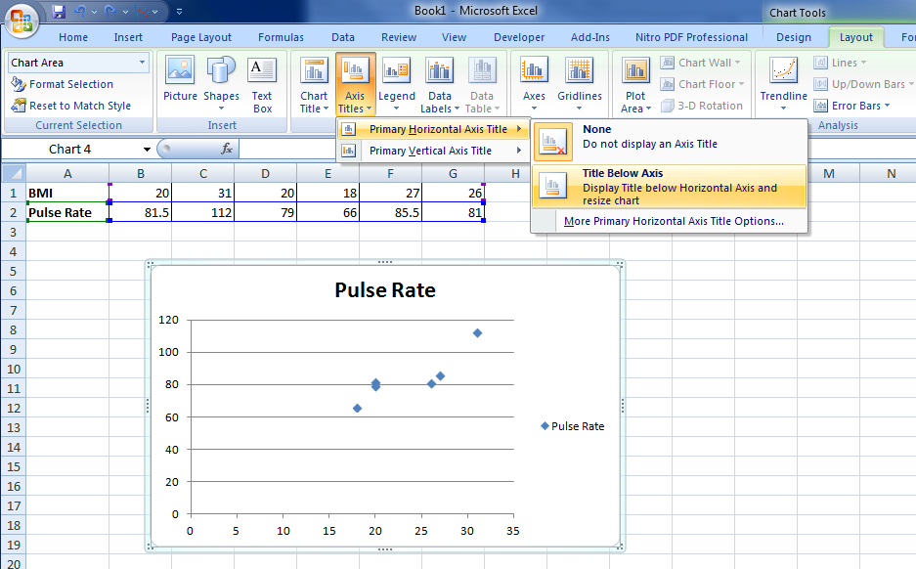
STEP 3: Edit Scatterplot
- Edit the axis titles and plot title by completing the following:
  - Select Layout from top menu, then Axis Titles from the Labels submenu.
  - For the horizontal axis, select Primary Horizontal Axis Title and then Title Below Axis, as illustrated below
  - Edit (change) the horizontal axis title to your own title.
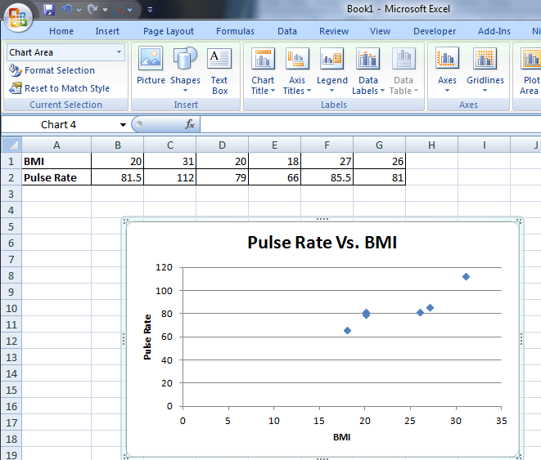
  - To edit the vertical axis title, select Primary Vertical Axis Title and then Rotated Title.
  - Edit (change) the vertical axis title to your own title.
  - To edit the chart title, select Chart Title under the Labels submenu and then selecting Above Chart.
  - Edit (change) the chart title to your own title.
  - To delete the legend, select Legend under the Labels submenu and select None.

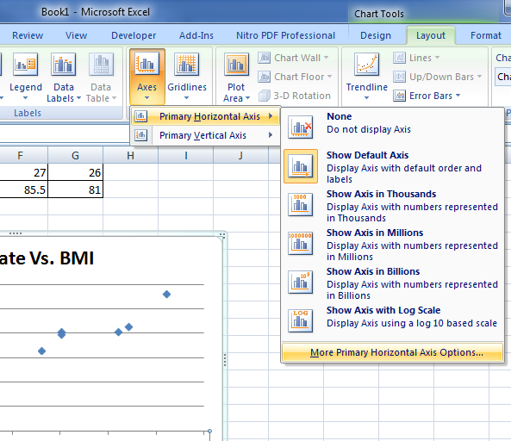
- Set the Min-Value and Max-Value for the x-axis and y-axis.
For the x-axis –
  - Under Layout on the top menu, select Axes under the submenu, then select Primary Horizontal Axis, followed by More Primary Horizontal Axis Options (bottom of the sub-menu panel).
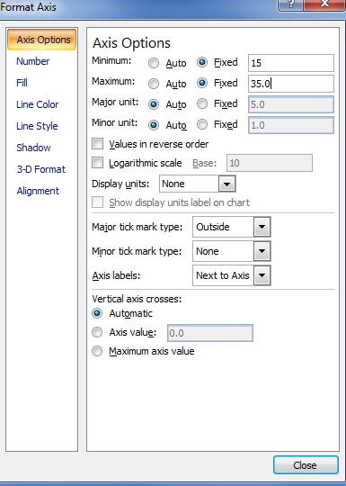
  - On the Format Axis window and under Axis Options, Select Fixed for Minimum and Maximum values; enter the desired minimum and maximum values.
For the y-axis –
- Repeat steps a-b above, as completed for the x-axis.

STEP 4: Review Scatterplot
- Check your scatterplot for accuracy.
- If you need to make corrections, go back to the previous steps.
STEP 5: Analyze Your Scatterplot
Write an explanation of the relationship between BMI and pulse rate.

- Is there a difference between male/female data in the relationship BMI and systolic blood pressure?
(Note: The following illustrations assume that the class data in Section A was organized such that the first three data represent male data and the last three data represent female data.)
STEP 1: Enter Data
- Type ‘Male’ in Cell A4 and ‘Female’ in Cell A8.
- Type ‘BMI’ in Cell A5 and in Cell A9.
- Type ‘Pulse Rate’ in Cell A6 and Cell A10.
- Enter all BMI values for the males in the class in Row 5, and the BMI values for the females in the Class in Row 9.
- Enter the pulse rate values for the males in the class in Row 6, and the pulse rate values for the females in Row 10.
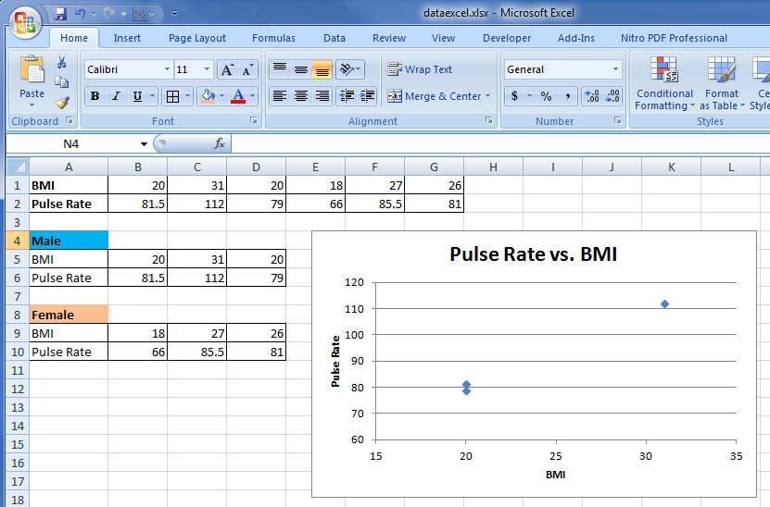
STEP 2: Create Scatterplot for Male Data
- Create the scatterplot for the male data by following all steps under Question A.

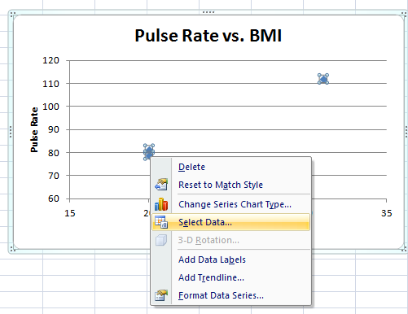
STEP 3: Add Female Data to Scatterplot
- Select the Scatterplot by left clicking the mouse.
- Select the male data points by right clicking on the mouse and Select Data.

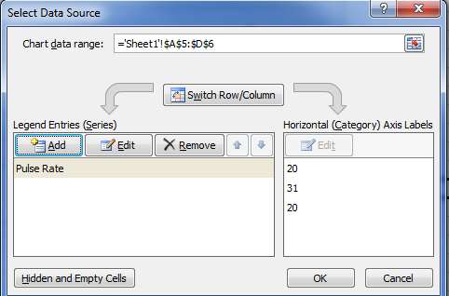

- In the Select Data Source window, click on Add.
- In the Edit Series window, type ‘Female’ in the Series name field.
- Place the cursor in the Series X values and type: ‘=Sheet1!$B$9:$D$9’ (Note: Change D to the last column letter of your data.)
- Place the cursor in the Series Y values and type: ‘=Sheet1!B$10:$D$10’ (Note: Change D to the last column letter of your data.)
- Click Ok.

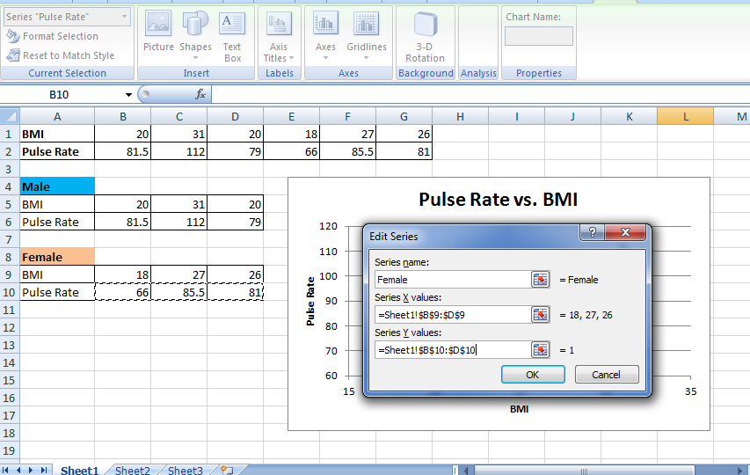

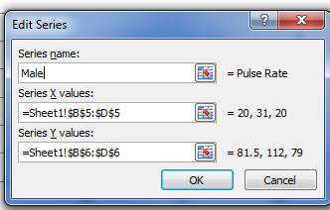
- Edit the title of the data series for Male data, by selecting Pulse Rate and then clicking on Edit.
- In the Edit Series Window, type ‘Male’ in the Series name field. Click Ok.

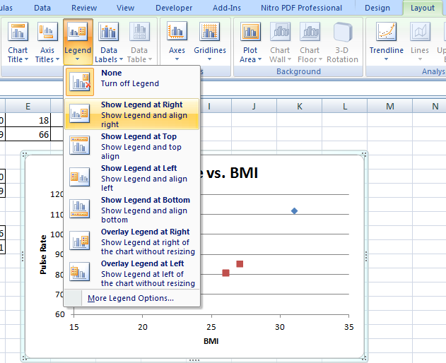
- Add a Male and Female Legend
- Under Layout in the top menu, select Legend in the Labels submenu, then select Show Legend at Right.

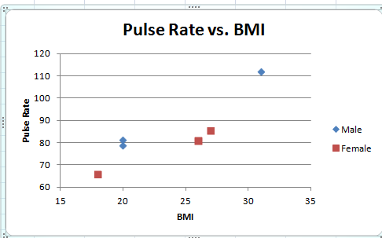
- The legend Male and Female will be added to the scatterplot (as shown at right).

STEP 4: Review Scatterplot
- Check your scatterplot for accuracy.
- If you need to make corrections, go back to the previous steps.
STEP 5: Analyze Your Scatterplot
Write an explanation of the relationship between BMI and pulse rate.

