Teacher’s Guide - Assembly of Model Ear Canal

- Cut tubing with scissors or pocket knife to approximately 1.5 to 2 inches long. 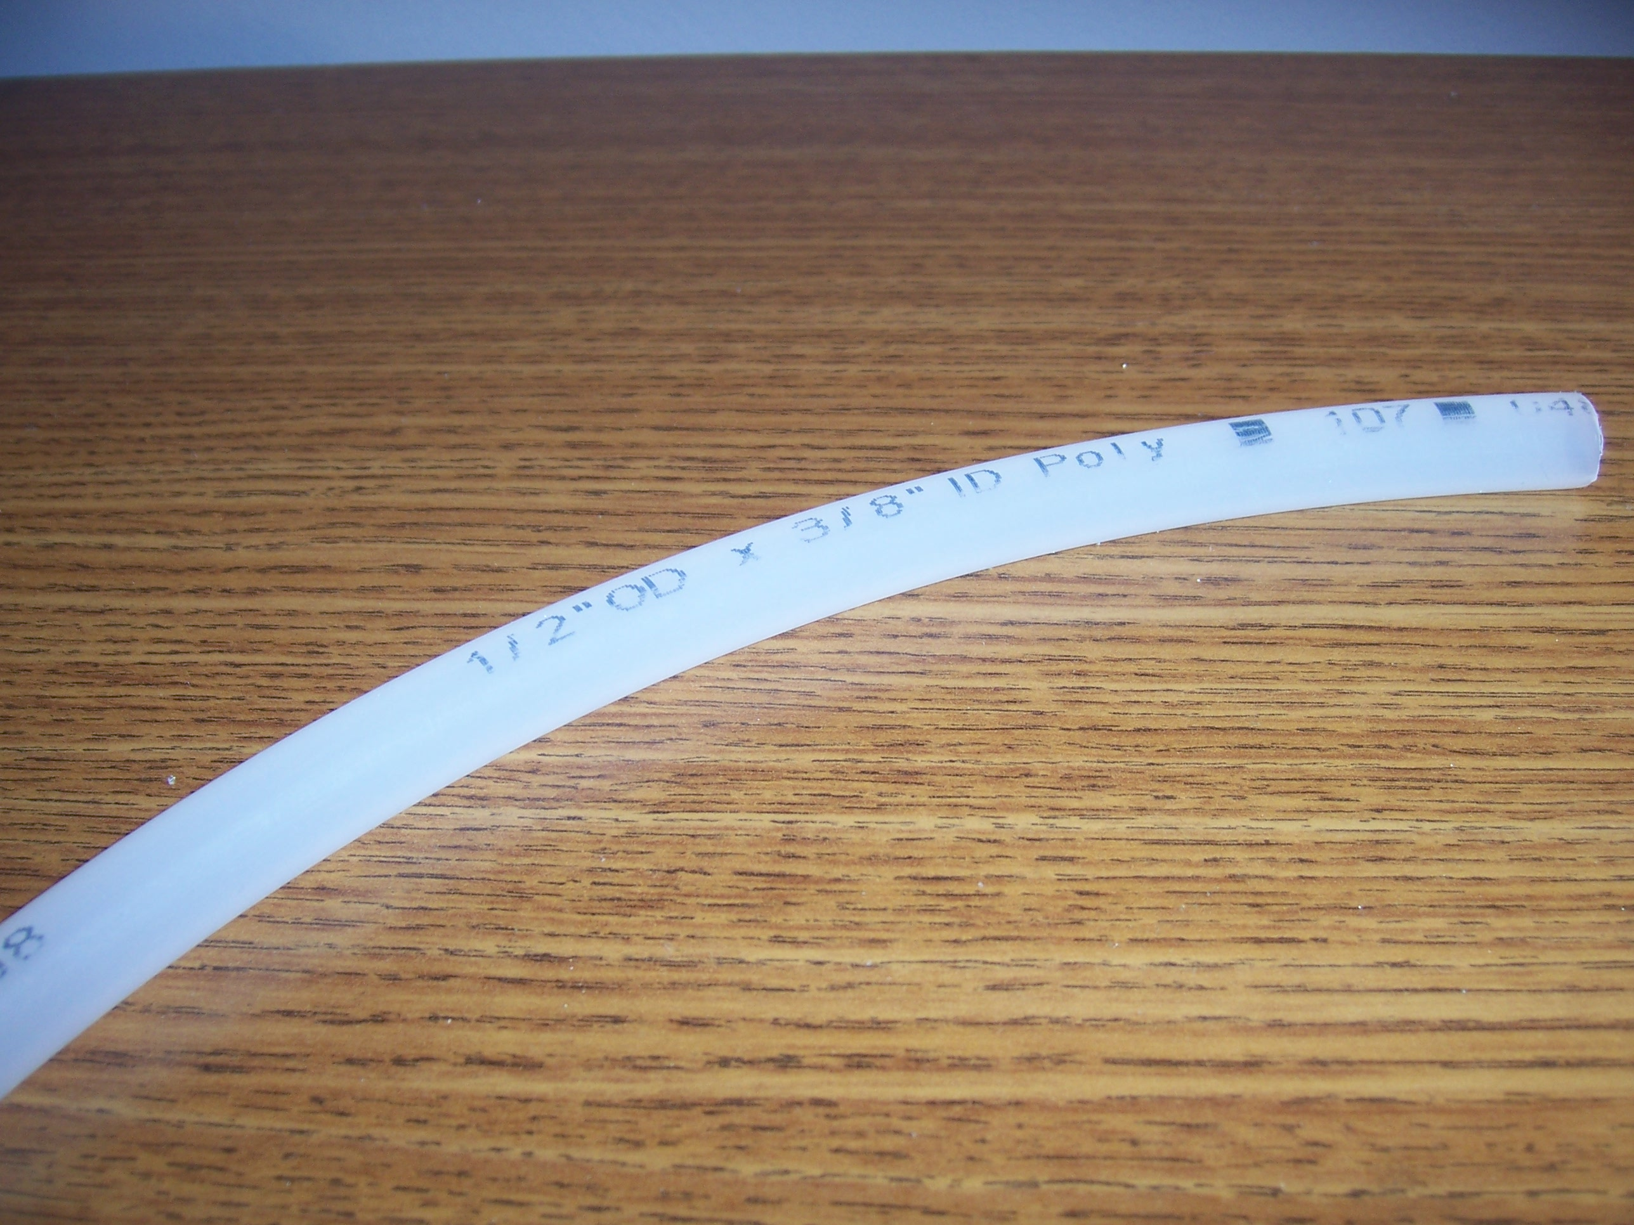

- Warm hot glue

- Connect tubing to pot. Apply one layer of hot glue around pot’s bottom, place the tubing, then surround tubing/pot connection with another layer of hot glue for security.
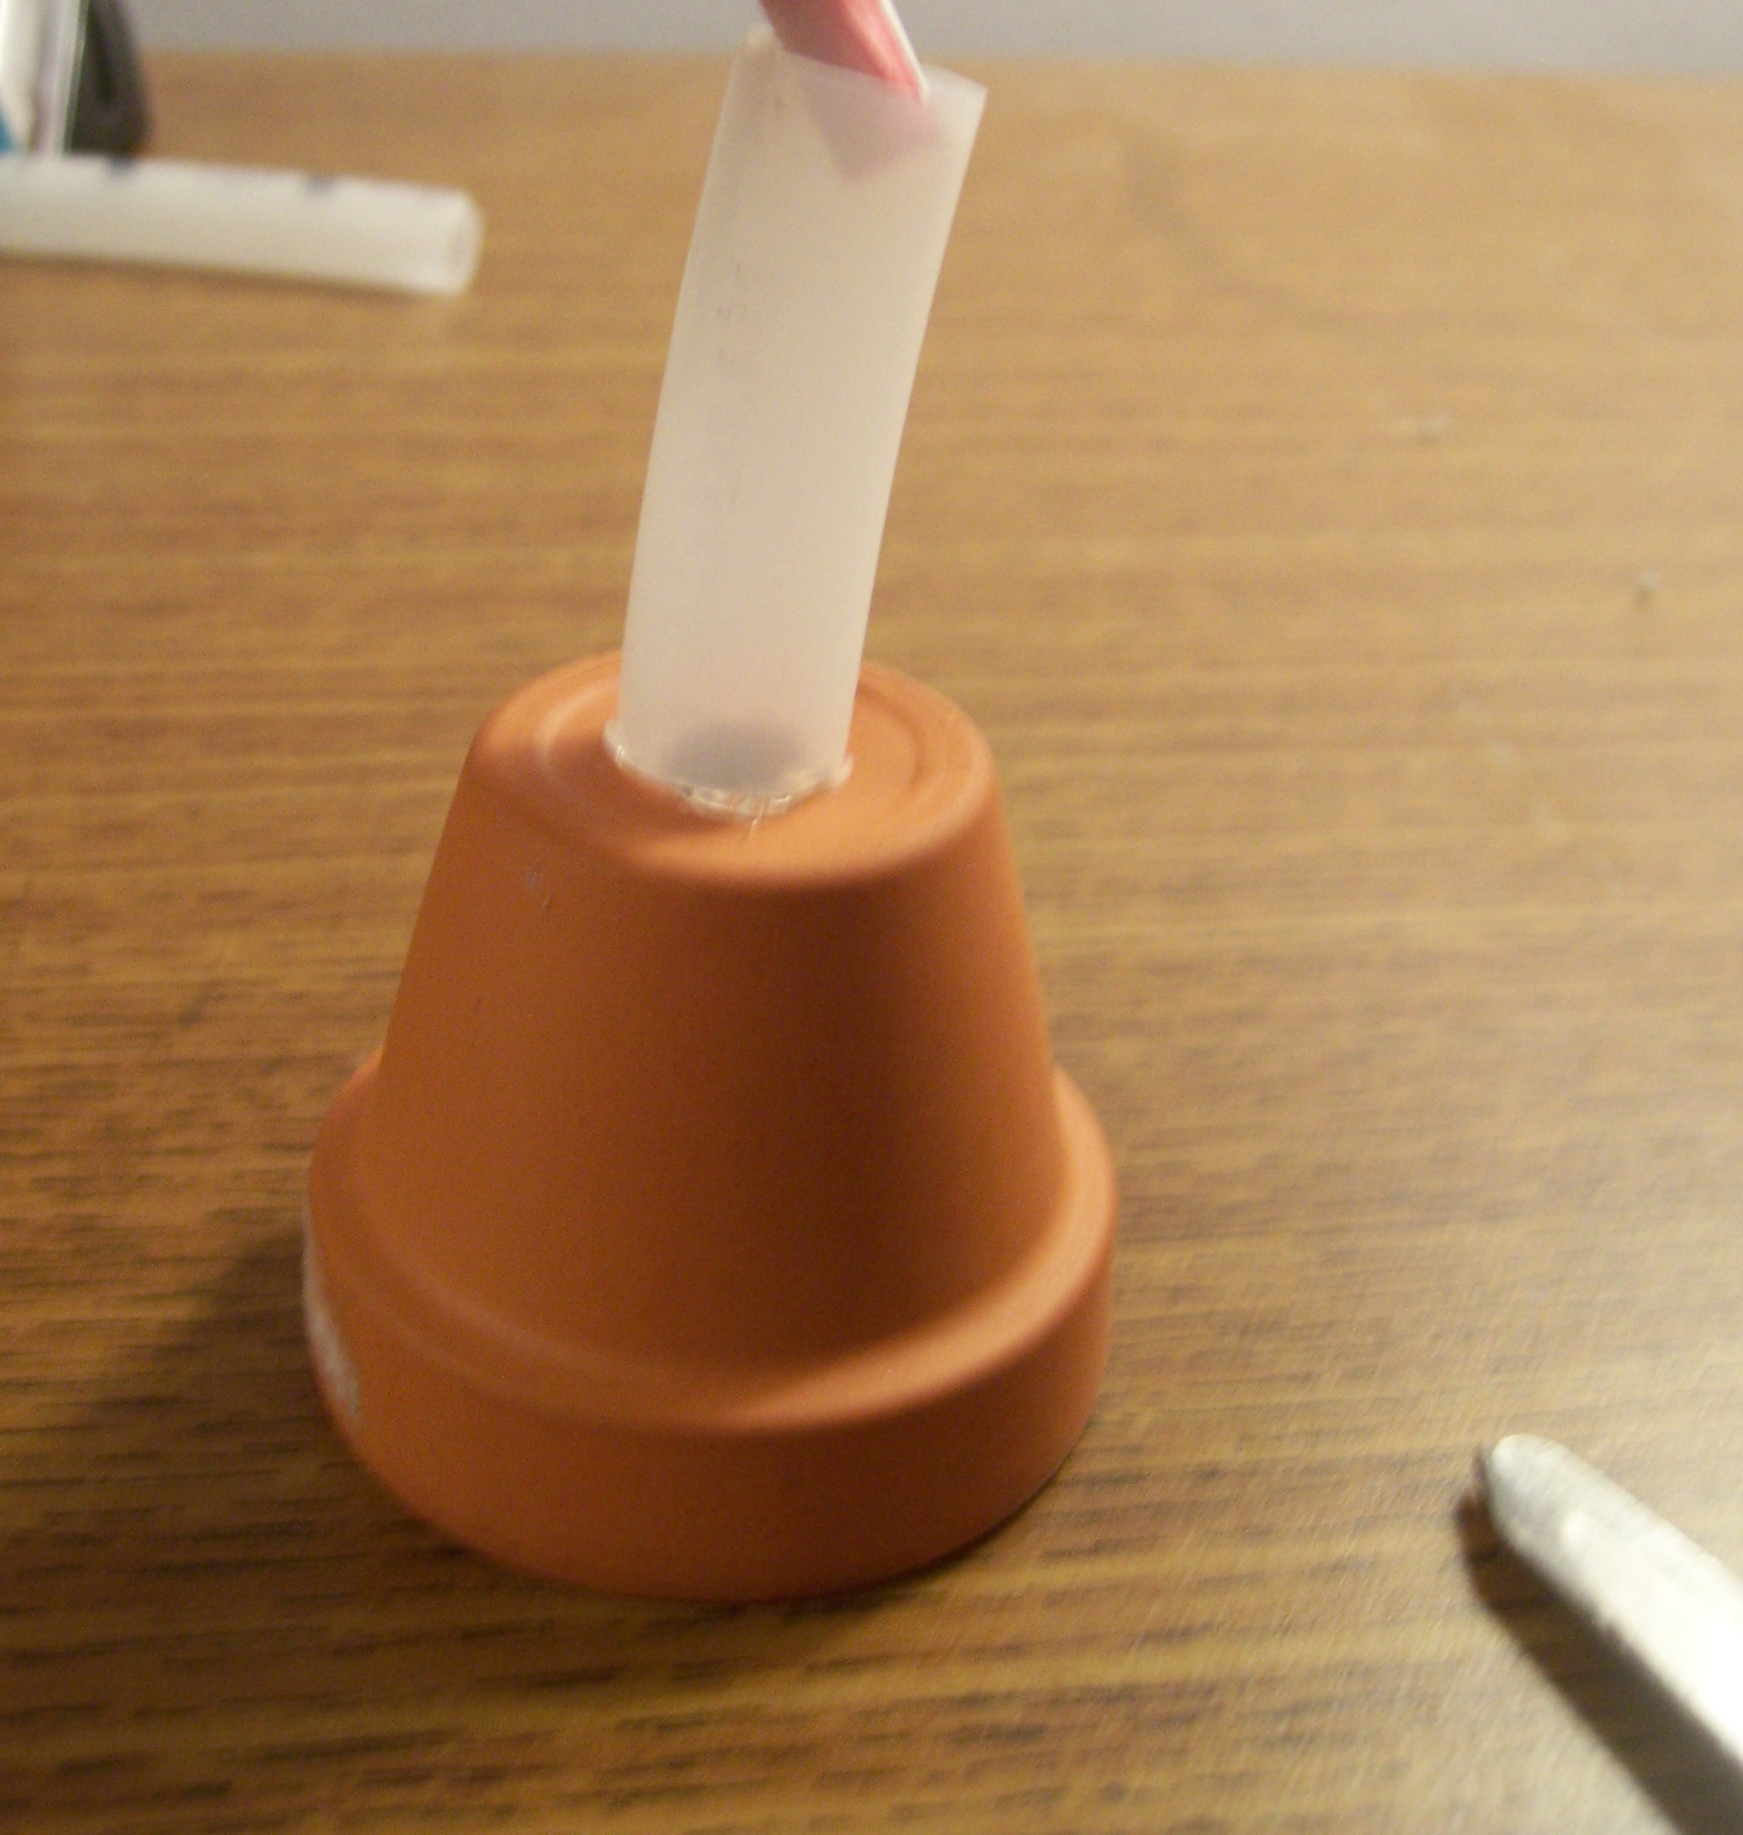

- Cut squares of plastic from veggie bags.

- After hot glue dries, place veggie bag cut outs over the open end of tubing and secure with an O-Ring.
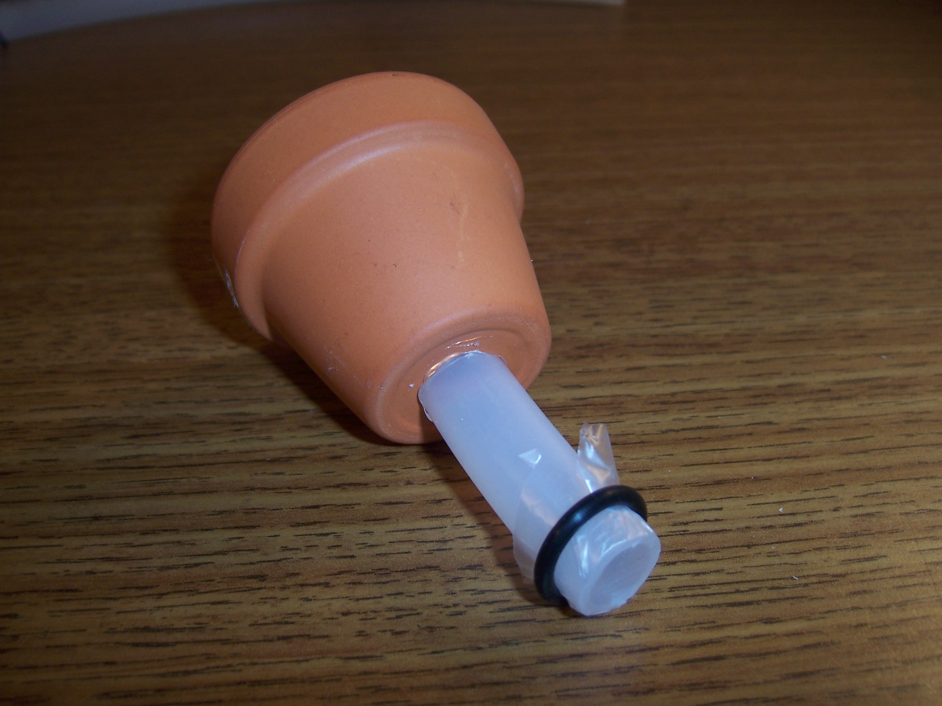

- Place the entire assembly into a PVC pipe connector.
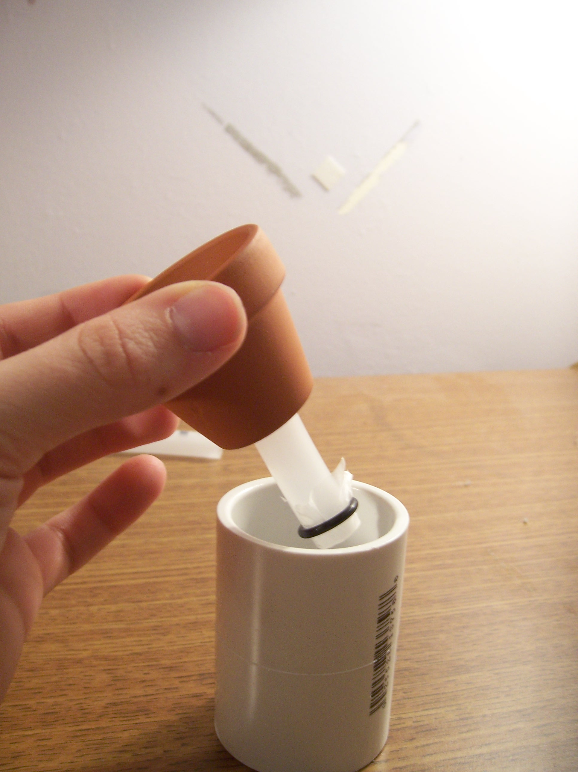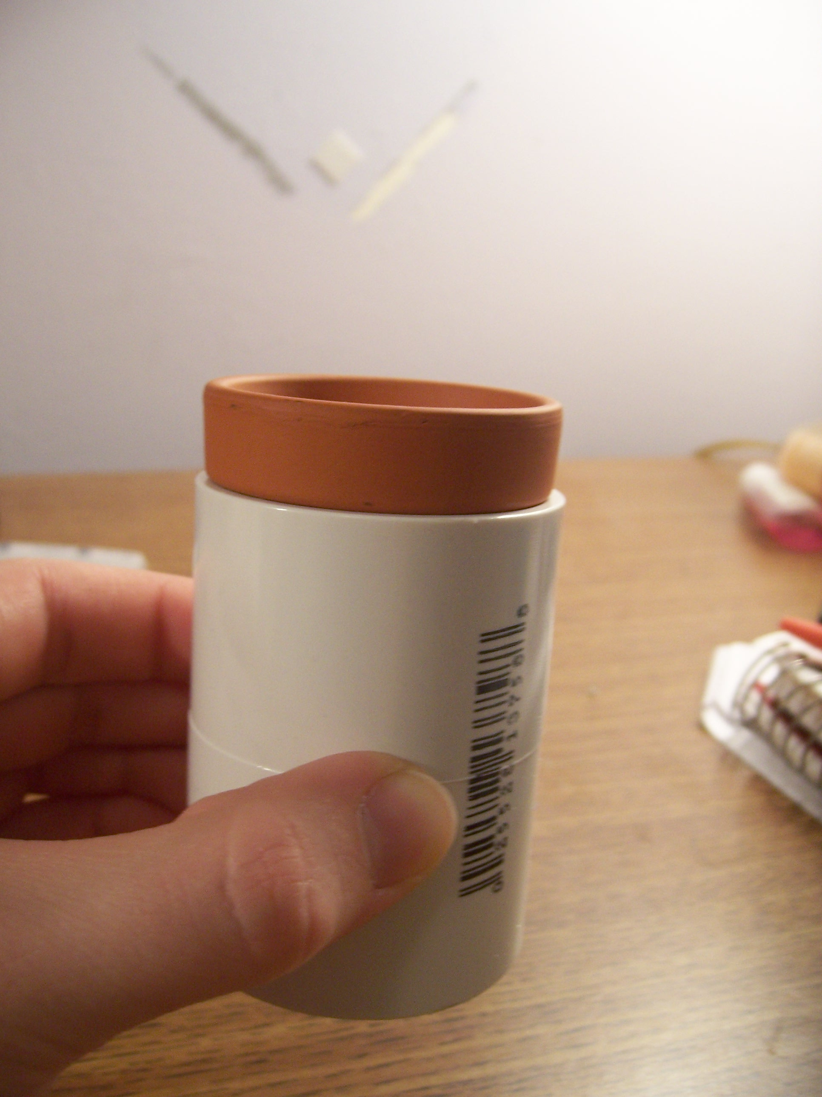

Occasionally, students will puncture the “ear drum”
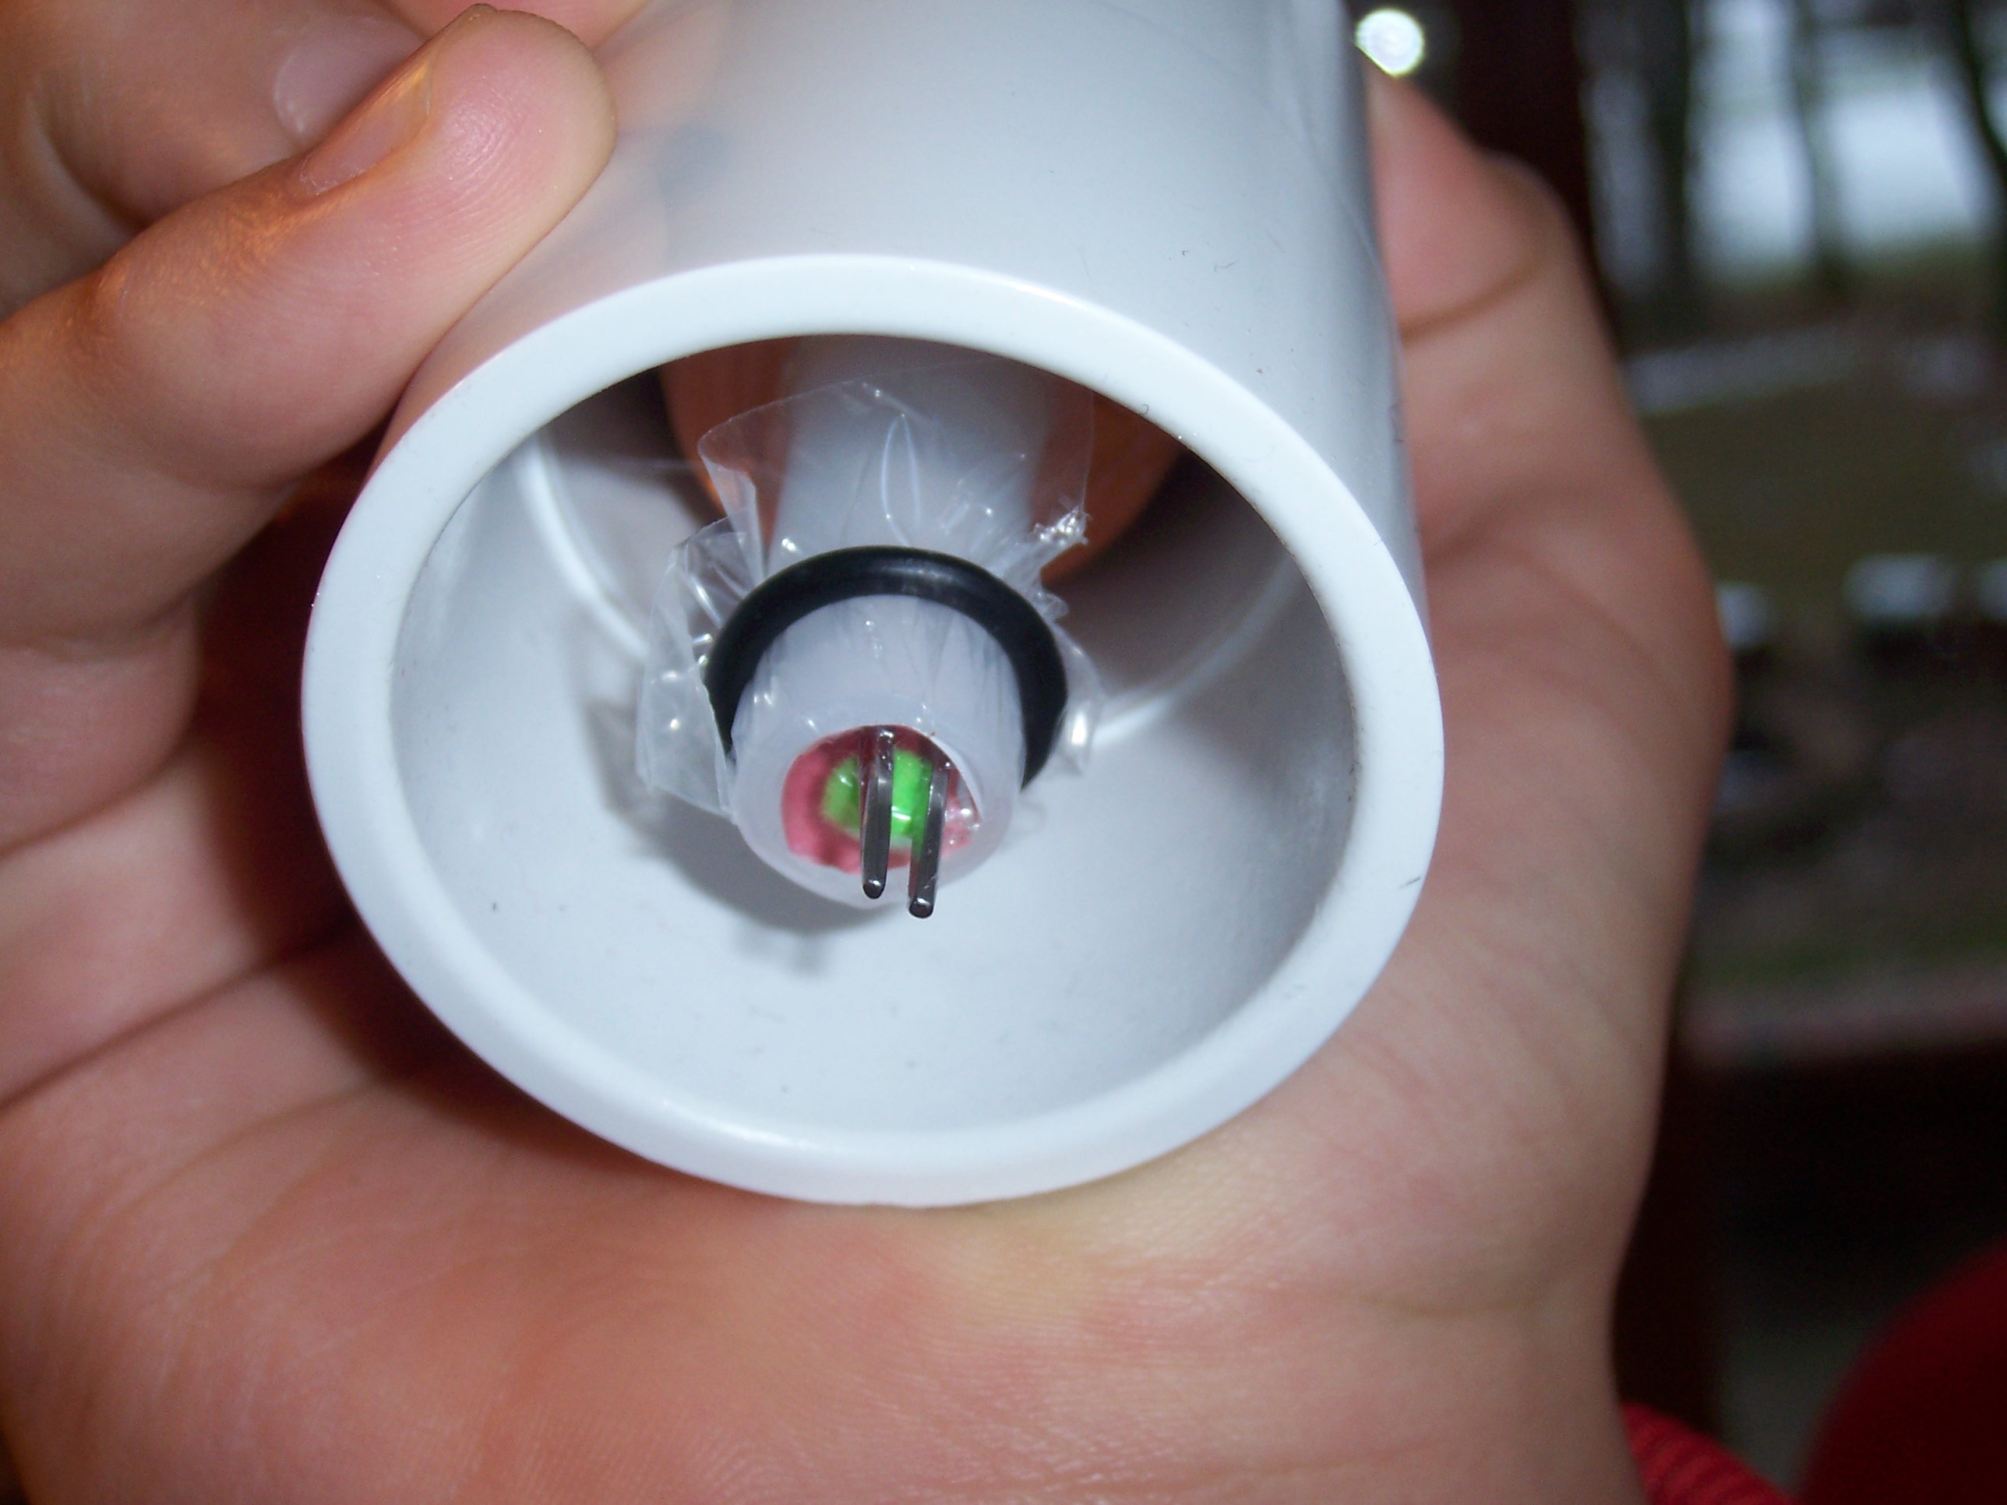
Simply remove the O-ring and cover with a new piece of plastic.

Example of Supplies for use:
