Activity Sheet 4 Name: ________________________________

Examine the EKG below:

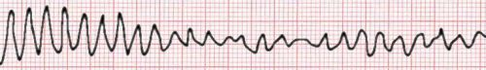
Time
Voltage

Compare the EKG Wave above with a healthy EKG.

Does the Amplitude look normal? _____________________________________________________________ ______________________________________________________________________________________________________________________________________

What about the Frequency? __________________________________________________________________ ______________________________________________________________________________________________________________________________________

What about the Pattern? ____________________________________________________________________ ______________________________________________________________________________________________________________________________________

Would a healthy heart produce an EKG like this? _____________________

What parts of the heart could cause this EKG? (Hint: Use all of the resources that you have been given!) ______________________________________________________________________________________________________________________________________________________________________________________________________________________________________________________________________________

