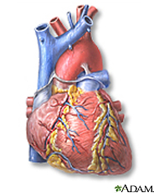
Artificial Heart Quick Design Challenge
Your Engineering Design Challenge
Design an artificial heart:
- First, choose which material you would use for the heart tissue, and which you would choose to supply the “juice” (electricity)!
- Then write one sentence for each material, explaining why you chose it.
Possible muscle materials (choose one)
- rubber
- silk
- aluminum foil
Possible power supply (choose one)
- power cord
- car battery
- watch battery
- Explain your choice of your MUSCLE material?

- Explain your choice of your POWER material?
Image source: ADAM, Medline Plus, U.S. National Library of Medicine, National Institutes of Health: http://www.nlm.nih.gov/medlineplus/heartdiseases.html

