Sonoran Desert Community - Species Information

The Sonoran Desert, like any ecosystem, has abiotic and vegetative characteristics that define it within a specific biome. Its species have special adaptations to support their existence within the limiting factors of their environment. Various species share interrelated connections through these evolved relationships with one another.
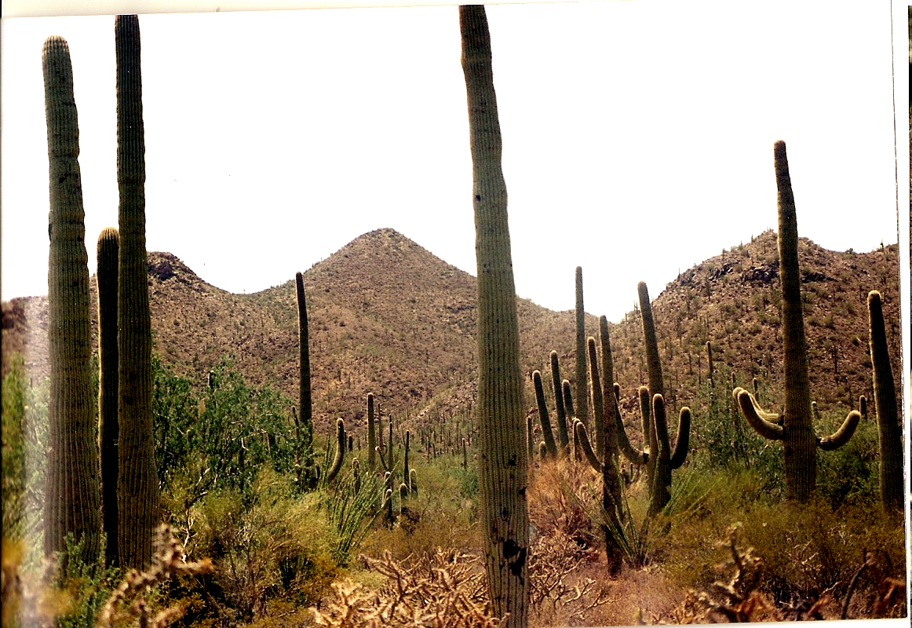

Saguaro cacti
Author’s own photo taken outside of Tucson, AZ

Saguaro (Carnegiea gigantea)
*40 – 75’ tall at maturity
*Flowers are 3” white and bloom from May – June
*Produces sweet, pulpy red fruits
*May live 200+ years
*Do not begin to flower until 55 years of age when approx. 8’ tall
*Cactus doesn’t begin to branch into arms until between 50 – 100 years
*Arms increase fruiting potential
*Pleated stems allow for expansion to increase water storage
*Flowers must be animal pollinated for fruit to develop
*White-winged dove are important pollinators
*Fruits and their seeds are also eaten by doves, squirrels, insects and other mammals
*Seedlings have low survivability and require the protection of a nurse plant such as the Ironwood tree
http://wc.pima.edu/~bfiero/tucsonecology/plants/cactuses_sagu.htm
- Saguaro reproductive output is relatively independent of precipitation levels. They fruit abundantly every year, but bear more fruit in dry years. Saguaro flowers and fruits are used by almost every member of the Sonoran Desert bird community as well as by several bat and bee species (Alcorn et al. 1959, Haughey 1986, Schmidt and Buchmann 1986, Steenbergh and Lowe 1977). The large number of consumers of saguaro nectar, pollen, and fruit attests to the importance of this plant as a resource for desert animals.
- http://www.desertmuseum.org/pollination/doves.php
Nutrient Source: Saguaro is not only the most frequent item in the dove's diet (Fig. 2), it is also the primary source of incorporated carbon for a large fraction of the breeding season (Fig. 3). In July, during the peak of saguaro fruit consumption, the isotopic composition of the doves' tissues was almost indistinguishable from that of saguaro. In other words, during this time of year, doves are deriving nearly all of their nutrients from saguaro fruit. In fact, the distribution of breeding western white-winged doves broadly coincides with the distribution of saguaros in Arizona and Sonora (Cottam and Trefethen 1968, Turner et al. 1995). http://www.desertmuseum.org/pollination/doves_more.php
*Nest in large desert trees such as the Ironwood http://www.desertmuseum.org/pollination/doves_more.php
- Western white-winged doves travel from their wintering grounds (southern Sinaloa, to Guerrero and Oaxaca) to the Sonoran Desert arriving as saguaros begin blooming in April. http://www.desertmuseum.org/pollination/doves_more.php
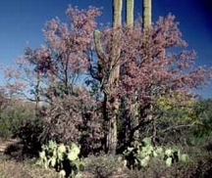

http://www.blueplanetbiomes.org/desert_ironwood.htm

Ironwood Tree (Olneya tesota)
*Member of legume (pea) family
*Reaches 35’ in height
*Flowers are pea-shaped and produce a brown hairy pea pod containing multiple seeds
*Found almost entirely in the Sonoran Desert
*One of most densest woods in the world
*Currently over-harvested and leading to them now being protected
* In addition to providing precious shade in the summer, these trees provide protection against winter frosts (critical in the life of many young plants including the saguaro), enrich the soil with nitrogen (through a special relationship they have with nitrogen-fixing microorganisms), and provide food, shelter, and materials for humans and nonhumans alike.
http://wc.pima.edu/~bfiero/tucsonecology/plants/trees_di.htm
*Nurse Plant: Saguaros and other large cacti of the Sonoran desert develop only slowly from seeds - the seedlings might take 2-3 years to reach a height of only 3 cm. During this time they are very vulnerable to drought in the intense exposure of the sun, so they almost invariably develop in the shade of a tree or shrub - a "nurse plant". For example, the image below shows a young saguaro - about 40 cm tall and probably 15 years old. It has grown up in the shade of a shrub (limber bush). Go to site and look at pictures
http://www.biology.ed.ac.uk/research/groups/jdeacon/desbiome/nursery.htm#top

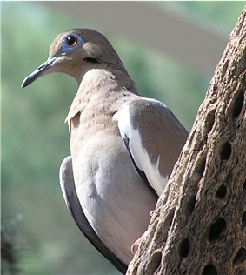

Adult White-winged Dove, Zenaida asiatica. Copied from nl:Afbeelding:Witvleugduif.jpg. Taken by J. Folmer at the North Carolina Zoological Park. This is a file from the Wikimedia Commons.

White-winged Dove (Zenaida asiatica)

*11.5” long
*Migratory – move in to AZ during spring and summer
*Important pollinator and seed disperser for Saguaro cacti
http://wc.pima.edu/~bfiero/tucsonecology/animals/birds_wwdo.htm
*Feed on pollen and nectar of the saguaro flowers
- Western White-winged Doves are important pollinators of the saguaro cactus. This behavior serves them well since they also feed on saguaro fruits and seeds. Although they are primary seed consumers, White-winged Doves also serve as dispersers of saguaro seeds. Some of the seeds the doves regurgitate and feed to their young fall to the ground, concentrating seeds beneath the nest. Since saguaro seedlings require shade to become successfully established, the doves may be inadvertently placing saguaro seeds in some of the most viable spots for development beneath their nest trees.
- http://animaldiversity.ummz.umich.edu/site/accounts/information/Zenaida_asiatica.html
- Western White-winged Doves’ dietary preferences lead them to migrate into the Sonoran Desert to breed during the hottest and driest time of the year. Their paradoxical arrival at such a harsh season is tied to the flowering and fruiting of columnar cacti such as the saguaro (Carnegia gigantea). Flower pollen and nectar, and subsequent fruits and seeds, provide virtually all the needed food and moisture required by desert White-winged Doves from May to mid-July. This food supply is consistently dependable, for even in drought years, columnar cacti flower abundantly in the Sonoran Desert.
- http://animaldiversity.ummz.umich.edu/site/accounts/information/Zenaida_asiatica.html
- White-winged doves are saguaro specialists, and they rely on saguaros almost solely for nutrients and water during the breeding season. Breeding white-winged dove distributions broadly overlap saguaro distributions in the Sonoran Desert. While white-winged doves are important saguaro pollinators, and they are also the main seed predators of saguaros. Thus, saguaros and white-winged doves maintain an asymmetrical ecological interaction
- http://www.desertmuseum.org/pollination/doves.php
- The dramatic white-winged dove population fluctuations in Arizona in the last 150 years can be explained largely by changes in human perceptions of doves (as pests, game, or fragile resources) and by how humans have used the land that they share with doves and saguaros (Alcock 1993). Populations of white-winged doves associated with agricultural fields and riparian thickets went through several declines in the last century related to over hunting, destruction of nesting habitat, and reduction in cereal production (O'Connor 1939, Neff 1940, Smith 1983, Brown 1989). The morning feeding flights of white-winged doves that were described by Cottam and Trefethen (1968) as "one of the great natural wonders of Arizona" are a thing of the past. They may have been artificial, existing only with agricultural activities. In the words of John Alcock (1993), "we have played god with the white-winged dove."
- http://www.desertmuseum.org/pollination/doves.php
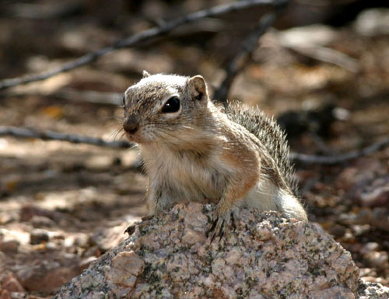

http://www.flickr.com/photos/pcoin/99075485/in/photostream/

Harris’ Antelope Squirrel (Ammospermophilus harrisii)
*4-5 oz
*White stripe runs along both sides of the body
*Tail held above back
*Omnivorous feeding on fruits and seeds
*One of few mammals that is diurnal and seen during the middle of the day feeding
*Diurnal because it’s adapted to hyperthermia – when body temp reaches lethal levels
*Flatten bodies against cooler ground in the shade to lower body’s temp
http://wc.pima.edu/~bfiero/tucsonecology/animals/mamm_hasq.htm
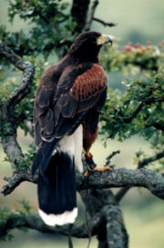

This is a file from the Wikimedia Commons.
Photo of a male adult Harris Hawk, taken in the Lake District, northern England.
Bird owned by Gary Worley, National School of Falconry, Cumbria, England.
Photo taken by, and copyright of, Charles Verrier.
Uploaded on 8 September 2004

Harris’ Hawk (Parabuteo unicinctus)

*21” long with a wingspread of 46”
*Very dark bird with rufous shoulders and leg feathers
*White at base and tip of feathers
*Feed on reptiles, mammals and birds
*Cooperative hunting between 2-5 hawks
*Common to see multiple hawks in branches of Saguaro
http://wc.pima.edu/~bfiero/tucsonecology/animals/birds_haha.htm
- Because Harris's hawks in Arizona are primarily restricted to the Sonoran Desert, development of natural areas for real estate and agriculture is the biggest threat to the population. http://www.azgfd.gov/w_c/nongame_harris_hawk.shtml
- Video on hunting technique
- http://video.nationalgeographic.com/video/player/kids/animals-pets-kids/birds-kids/hawk-harris-kids.html

