ACTIVITY 6 - ADAPTATIONS FOR BIRD FLIGHT

Pre-Question:
Birds, alongside bats and insects, have the extraordinary ability of flight. Please answer the following questions to see how acquainted you are with their abilities.
1. How do species of birds differ in their flight patterns? List as many differences as you can.

2. How might studying these different patterns be beneficial to man? Can you think of any specific examples? List them.

I. Bird Flight and Wing Shape http://www.nhm.org/birds/guide/pg018.html
Read this article and answer the questions that follow.
1. Name the four main forces that affect the flight of a bird.

2. What is lift?

3. What is drag?

4. What is the general shape of a bird’s wing? ___________________________

5. Study the diagram:
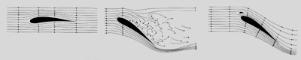

Explain how the low pressure zone along the upper surface of the wing is created and thus causes the wing to be sucked up.

6. Study the wing shapes and identify them to their type of flight. Next, list
2 examples of birds with this wing shape.
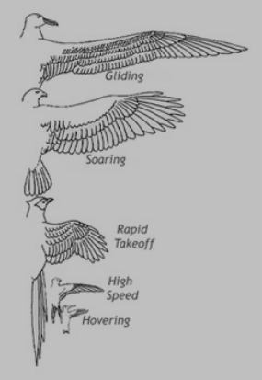
A_______________________________

1.________________________

2.________________________
A

B_______________________________

1._________________________

2._________________________
B

C_______________________________

1._________________________
C
2._________________________

D_______________________________
D

1._________________________
E
2._________________________

E_______________________________

1._________________________

2._________________________

7. Birds fly by flapping or gliding. Hummingbirds can also __________________. In order to do this, some hummingbirds flap their wings as many as _____________ times per second.

8. Explain the special shoulder joint adaptation that allows a hummingbird’s wings to perform this feat.

II. Bird Flight http://www.earthlife.net/birds/flight.html
1. What governs the dynamics of bird flight?_____________________________

2. Flying is a balance between what two sets of forces?

*_____________________________________

*_____________________________________

3. What shape is a bird’s wing? _________________ How does this affect lift?
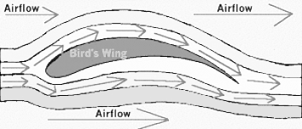

4. The most efficient wings are those which supply _____________ while

reducing ___________________. Two examples of birds with this wing shape

are ____________________ and_________________.
5. What is aspect ratio’s definition?

6. What is the formula for wing loading?

7. What are passerine (songbirds) and pheasants adapted for?

8. What are waders (blue heron) adapted for?

9. What are eagles and vultures adapted for?

10. What are albatrosses adapted for?

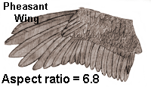 | 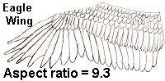
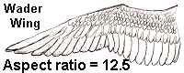 | 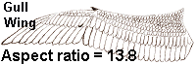

III. Wing Shapes and Flight
http://www.stanford.edu/group/stanfordbirds/text/essays/Wing_Shapes.html
1
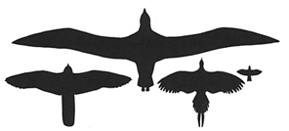

Top: Albatross.
Bottom, left to right: falcon, pheasant, passerine.

1. Name another bird capable of hovering:_______________________

2. How expensive is it for a hummingbird to hover?

3. What is the difference between an updraft and a thermal?

4. How do vultures fly using thermals?

5. Vultures eliminate drag by doing what to their wing feathers?
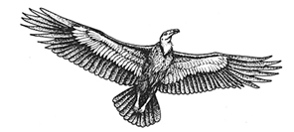

6. How long is an albatross’ wing?____________________

7. What is slope lift?

8. How do albatrosses use this to fly?

