Light Experiment: Attenuation

Introduction:
This lab shows the mathematical relationship between the attenuation of x-rays through an object and the thickness of the object. This relationship will be used to find the attenuation coefficient, a measure of a material’s ability to absorb and scatter x-rays, of transparency film.

Initial Thoughts:
- How is a shadow like an x-ray image?
- How do you think the shadow of a transparent object will change as the thickness of the object increases?

Materials:
Item | Quantity | Cost
Lamp | 1 | 8.39
Bulb (incandescent, 60 Watts) | 1 | 1.02
Aluminum foil square | ~12” x 12” | 0.02
New, clean transparency | 1 | 0.13
Printed light intensity scale | 1 | -----
Masking tape | ~12” | 0.02
Scissors | 1 | 1.89
Excel computer software | 1 | -----
 | Total Cost | 11.47
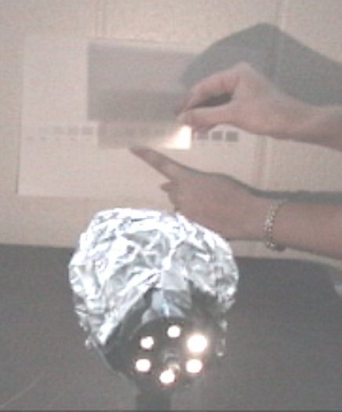
Method:
Figure 1. Comparing the shadow to the grayscale and collecting the data.
Tape the light intensity scale to a wall and set up the lamp to shine on the scale. (Do not turn on the lamp yet.) Cut the transparency into eight equal-sized sections. Take a piece of foil and cut a five mm diameter hole in the center of it. Next, cover the face of the lamp by wrapping the aluminum foil around it, making sure that the hole is in the center of the face of the lamp and that the aluminum foil does not cover up the vents in the back of the lamp. Safety Tip: Do not leave the lamp on for more than a minute at a time, as the foil traps heat and can cause the bulb to burst.
Thickness (# of sheets) | Light Intensity (% white)
0 | 100
1
2
3
4
5
6
7

Table 1. Record the grayscale numbers here.

Next, darken the room, turn on the lamp apparatus, and hold up a piece of transparency a couple inches from the wall to cast a shadow near the scale (but not on the scale). Match the intensity of the resulting shadow with a square on the scale, as shown in Figure 1. Tip: It is easier to distinguish the shade of gray in the shadow when one steps back to look at it. Record the intensity in Table 1 (previous page). Repeat the process with two sheets of the transparency stacked together, then three, and so on until the table is filled.
Next, use Excel to plot the natural logarithm of the shadow’s intensity versus the thickness of the attenuator. To do this, open Excel and follow the directions below:
- Record the values from Table 1 into the Excel spreadsheet.
  - Type the titles “Thickness” and “Light Intensity” into cells A1 and B1, respectively.
  - Type the thickness values in cells A2 to A9 and the intensity values in cells B2 to B9.
- Calculate and record the natural logarithm of the shadow’s intensity values into the excel spreadsheet.
  - In cell C1, type “Ln (Intensity).”
  - In cell C2, type “=LN(B2).”
    - When you hit enter, the cell contents should change to the number 4.60517 (the natural log of 100).
  - Select cell C2. Right click and select “Copy.”
  - Highlight cells C3 to C9. Then right click and select “Paste.” Hit the enter key.
    - Cells C3 to C9 should all be filled with numbers.
- Graph the natural logarithm of the shadow’s intensity vs. the thickness of the attenuator.
  - Highlight cells A1 to A9. Hold the control key and highlight cells C1 to C9.
    - The data in both columns A and C should be highlighted.
  - Click on “Insert” (on tool bar at top of page) and select “Chart.”
  - Click on “XY Scatter” and then click “Next>” and then “Next>” again.
    - The “Step 3 of 4-Chart Options” window should be on the screen.
  - Under “Titles,” type in a title for the graph and label its axes. Under “Legend,” deselect “Show Legend.” Click “Next>” and then “Finish.”
- Add the trendline to the graph.
  - Right click on one of the data points in the graph and select “Add Trendline...”
  - Under “Type,” choose “Linear” and under “Options,” select “Display equation on chart” and “Display R-squared value on chart.” Click “OK.”
    - The equation tells what the bestfit line through the data is.
    - The R² value indicates how well the data fits the line. The closer the value is to 1.0, the better it fits.

Conclusions:
- Do your data points fall along a relatively straight line? What does the equation of the best fit line tell you about the relationship between the attenuator thickness and the light intensity of the shadow?
As the attenuator thickness increases, the Ln(intensity) decreases linearly. This indicates that the intensity decreases too, but not linearly. R² values close to 1.0 indicate that the points fall along a straight line and that there is a change in beam intensity when attenuator thickness changes. (If the points fall exactly on a line that is horizontal, R² ≠ 0.)
- Convert Beer’s Law, shown below, to y = mx + b format, keeping in mind that Ln(A/B) = Ln(A) – Ln(B).
$\frac{\text{Intensity}}{I_{0}}=e^{−μ∗\text{Thickness}}$.
Compare the converted formula to the equation on your graph. What is the attenuation coefficient, µ, of the transparency film? What are the units of µ?
The attenuation coefficient corresponds to the negative slope of the best fit line. In the example attached, the attenuation coefficient, µ, is 0.039 sheets⁻¹. From Beer’s Law, the units of µ must cancel out the units of thickness, so in this lab, the units of µ are sheets⁻¹.
- If the attenuator were infinitely thick, what would you expect the light intensity of the shadow to be?
The light intensity would be zero.
- In what ways are visible light photons like x-ray photons?
Visible light photons are another form of electromagnetic radiation. Both types of photons interact with matter. That’s why as the attenuator thickness increased, fewer light photons were able to pass. This would hold true for x-ray photons too.
- In what ways are visible light photons different from x-ray photons?
X-ray photons are higher in energy (shorter in wavelength) than light photons. Therefore, x-ray photons will be able to pass through materials that will reflect light, such as skin and tissue in the body.
- Thinking about this activity, how is a shadow like an x-ray image?
A shadow is a representation of how light photons are attenuated by the medium they pass through, just as an x-ray image is a representation of how x-ray’s are attenuated by the medium through which they pass.

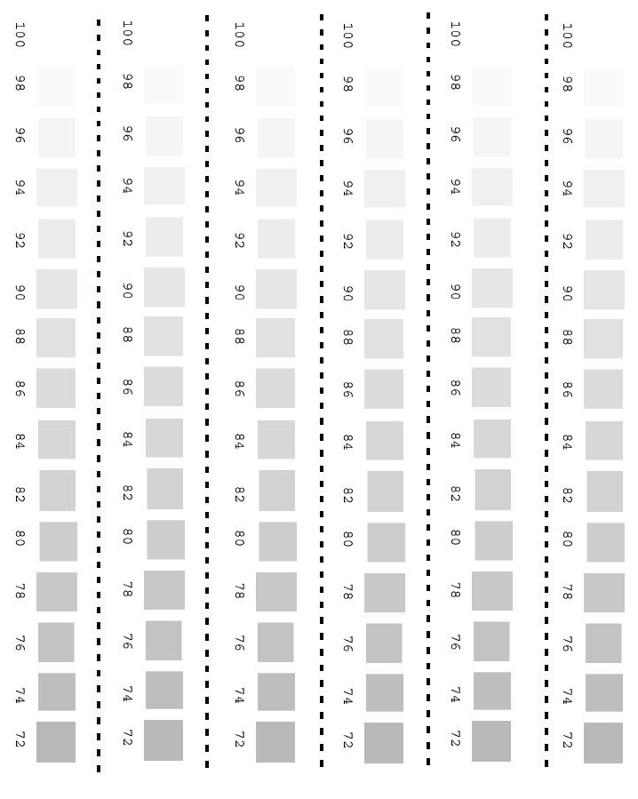

Sample Results for Light Attenuation Lab

 | A | B | C | D
1 | Thickness | Light Intensity | This equation gives | Ln(Intensity)
2 | 0 | 100 | =LN(B2) | 4.605170186
3 | 1 | 96 | =LN(B3) | 4.564348191
4 | 2 | 90 | =LN(B4) | 4.49980967
5 | 3 | 88 | =LN(B5) | 4.477336814
6 | 4 | 84 | =LN(B6) | 4.430816799
7 | 5 | 81 | =LN(B7) | 4.394449155
8 | 6 | 78 | =LN(B8) | 4.356708827
9 | 7 | 77 | =LN(B9) | 4.343805422

