Grand Challenge: Detecting Breast Cancer

Breast cancer is the second-leading cause of cancer death among women (Papas, 253). The American Cancer Society has indicated that mammography is the best early-detection tool available. It is able to detect cancer before – sometimes years before – physical symptoms are present (American Cancer Society, 13). It is recommend that women at or over the age of 40 have a mammogram annually (ACS, 13). Despite the fact that mammograms are the most effective early-detector of breast cancer, many women choose not to have them. Of all American women at or over the age of 40, only 54.9% have had a mammogram within the past year (ACS, 15).

One reason that women may not get an annual mammogram is pain. Mammography is quite painful for some women. In a summary of studies, between 0.2% and 62% of women reported some pain related to mammography. If the qualifier was changed from “pain” to “discomfort”, 90% of women answered that they had experienced this (Papas, 254). There are other forms of early-detection, breast-self exam (BSE) and clinical breast-exams (CBE), but these are not as effective as mammography.

Is there a way to detect the presence of tumors that isn’t as painful as mammography but more reliable and quantifiable than a BSE or CBE?

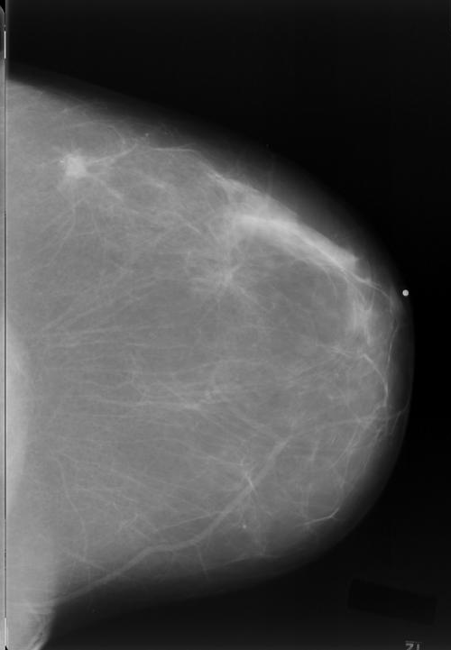
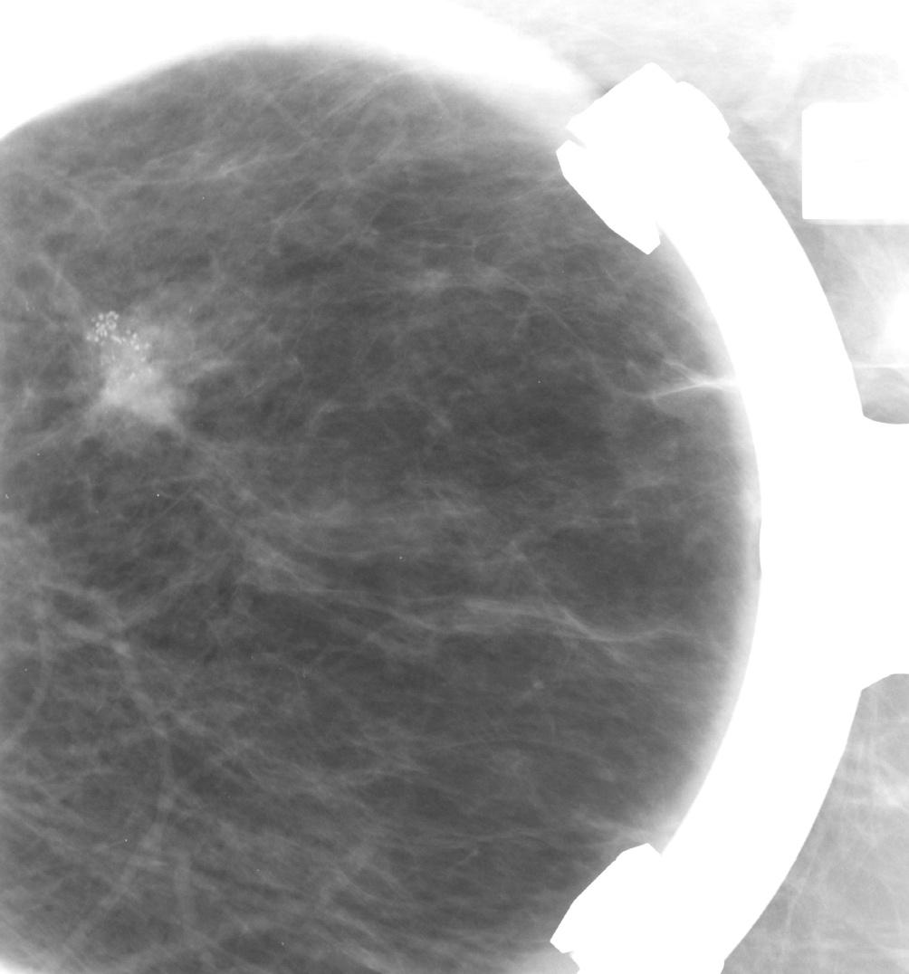

Figure 1: Mammogram images showing a speculated mass in the breast.
Images courtesy of Vanderbilt University Radiology Department.

Generate Ideas
Think over this question ON YOUR OWN. We won’t share ideas with anyone (yet). Jot down your ideas about the following questions:

- In your own words, describe the need in society which the challenge question is identifying.

________________________________________________________________________

________________________________________________________________________

________________________________________________________________________

- What are your initial ideas about how this need can be fulfilled?

________________________________________________________________________

________________________________________________________________________

________________________________________________________________________

- What background knowledge do you think you need to answer the question?

________________________________________________________________________

________________________________________________________________________

________________________________________________________________________

- What do you know about breast cancer and tumor detection already?

________________________________________________________________________

________________________________________________________________________

________________________________________________________________________

