Hooke’s Law

Purpose
To investigate the response of a hanging spring as mass is added.

Background
Robert Hooke proposed that the stretch of a spring is proportional to the force applied to the spring. This is commonly written as

where F is the force applied, k is the constant of proportionality, or spring constant, and Δx is the amount of stretch caused by the force. The negative sign indicates the spring force is a restoring force; in other words, the spring is always trying to oppose any forces applied to it.

Materials
physics stand | pendulum clamp
ruler / meter stick | slotted mass set
springs

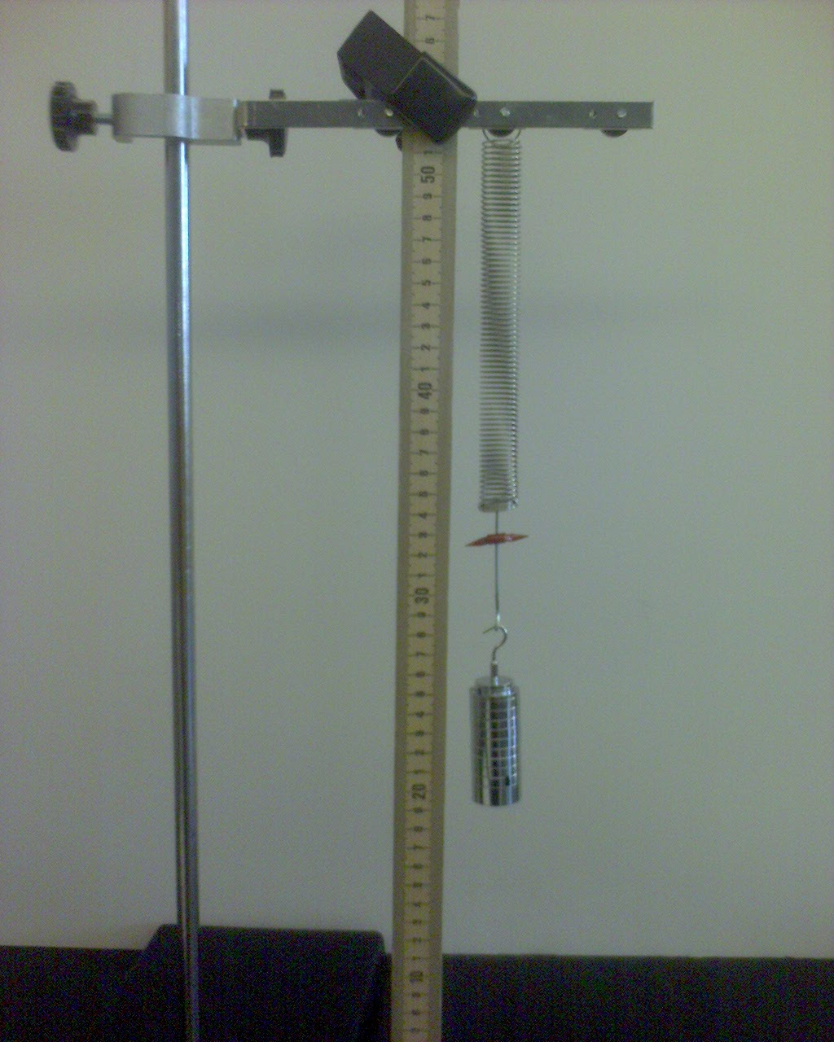
Procedure
- Set up lab station so that the spring is hanging from the pendulum clamp and your ruler (or meter stick) is also positioned in such a way that you will easily be able to read the displacements caused by the forces that you are applying to the spring. (see fig. 1)

- Note the equilibrium position (no force added) of the spring and note this in your data table.

- Your slotted mass set adds up to total of 250 g (± 2 g). Starting with just the base (50 g), slowly add mass to the spring until you have added all 250 g. After every addition of mass, stop and record the amount of stretch in the spring.

- After all data have been recorded, repeat steps 1 – 3 with a different spring.
Figure 1
One way to set up the lab.

Data

Spring 1 |  |  | Spring 2
mass (g) | force (N) | Δx (cm) | mass (g) | force (N) | Δx (cm)
0 | 0 |  | 0 | 0
250 |  |  | 250

Analysis
- Construct a graph for each spring showing the force vs. displacement of the spring. Show your trend line (with equation) and R² value clearly on your graph. You may put both graphs on one piece of paper as long as each graph is a full ½ page. (I recommend using Excel or Logger Pro.)

- What is the value of the slope for each spring? What does this slope represent?

- Compare the spring constants of the two springs. As the spring constant increases, what changes? In other words, if two springs have different k-values, how is their behavior different?

Application Questions

- A load of unknown mass is place in the rear of an 18-wheeler truck. The trucks rear shocks are instantly compressed 10.0cm. Consider the shocks acting as springs with a spring constant, k = 50,000N/m. What is the mass of the load the 18-wheeler just picked up?

- Earlier today, I performed our experiment with a different spring. I obtained the data below. Does the spring I used obey Hooke’s Law? Be specific in your explanation.
mass (g) | Δx (cm)
0 | 0
50 | 5
100 | 15
150 | 30
200 | 50
250 | 75

- Relate Hooke’s law to the stress-strain relationship we’ve been studying in class. You may refer back to your class notes. Please relate each corresponding variable for the two relationships.
$$\frac{F}{A}=E\frac{Δl}{l_{o}}$$

- Consider body tissue instead of a spring. Which equation would you use if you were now depicting body tissue with a known surface area, instead of a spring? What characteristics of the tissue would be represented by the constant (k or E)? Which constant would you use?

