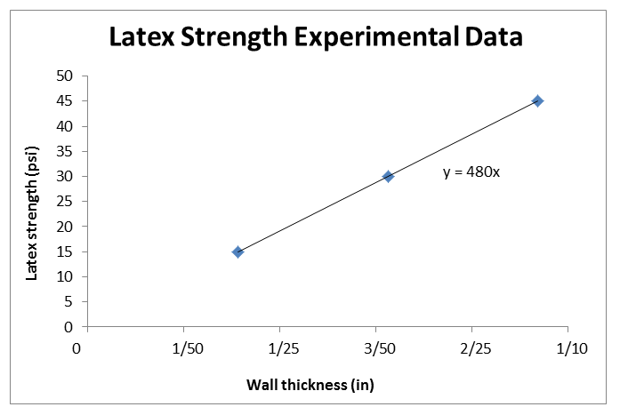
Linear Models from Experimental Data Worksheet Answer Key
Example Answers

- Answer the followings questions. Then, complete the table provided using the data you collected from the previous lesson.

- What is the independent variable in you experiment?
Wall thickness.

- What is the dependent variable in your experiment?
Latex strength.

- How many data points do you have on your graph?
3 (this should be equal to the number of tubes with different wall thickness tested).
This example graph uses example and estimated data; expect student graphs to vary, yet still show a linear trend.
Below are example answers; expect students’ data to vary from these since the results depend on the latex tubes used. It is recommended that teacher test in advance to obtain data.

Wall Thickness  (outer diameter) | Trial 1 Latex Strength | Trial 2 Latex Strength | Trial 3 Latex Strength | Average Latex Strength  (air pressure–psi)
1/32 in | Depends on your experimental results;  estimated ~15psi
1/16 in | ~30 psi
3/32 in | Depends on your experimental results;  estimated ~45 psi
1/8 in | example extrapolated ~60 psi
1/4 in | example extrapolated ~120 psi
1/2 in | example extrapolated ~240 psi
1 in | example extrapolated ~480 psi
ex extrap ~5/8 in | 300
Above are example extrapolated values (for Fig. 5 table) based on example data; expect your extrapolation from your measured data to be different yet reflect linear relationship.

- Copy the data points from the table into the graph provided on the upper right of this worksheet.
Label the x– and y–axes appropriately.
Be sure to use the same units and increments from the Excel chart for both variables.
For each data point, provide the numerical ordered pair.

- Now that you have plotted the data points, draw a straight line from the data point at the far left to the data point at the far right. Write the coordinates for these data points below.

Depends on experimental results
( x₁ , y₁ ) ( x₅ , y₅ )

- Write the slope between the two points.

Slope = (y₅ – y₁)/(x₅ – x₁)

- Using one of the coordinates from question 3 and the slope, write the equation of the line.

Equation: Depends on experimental results

