Interpreting Graphs Homework

- The graph below shows the relationship between scores received in French class and scores received in German for the same student.
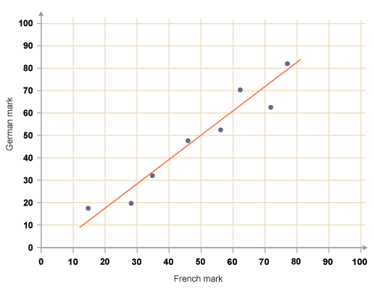

- What is the independent variable for this graph?

- What is the dependent variable for this graph?

- What can you assume about the relationship between number of French scores and German scores?

- Write the ordered pair for the data point on the far left and the data point on the far right.

- Calculate the slope between these two points.

- Use the slope to write the equation of the line passing through the two points in d).

- Use this equation to find the expected German score for a student who scored 50 in French.

- Does this expected German score make sense? Explain.

