Can You Resist This? Activity Handout
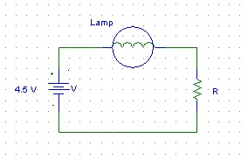
Figure 1: Circuit for this activity
Once all the circuit elements are in place, connect one end of the lamp wire to the positive end of the battery and insert the other end into J4.
- What happens? Does the lamp glow as brightly as it did the first time you saw it?

Notice that now, the electrical current is flowing from the battery, through the wires to the lamp, through the 10Ω resistor, through the black wire and back into the negative side of the battery. Refer to Figure 1 for a diagram of the circuit where R= 10Ω.
- Use Ohm’s law to figure out how much current is flowing through the resistor. Don’t forget units!

Now, move the wire from the lamp to J7. The circuit that is now formed can be referenced to Figure 1 where R=15Ω.
- Does the lamp burn as brightly?

- How much current flows through the resistor now? Use Ohm’s law again and don’t forget units!

Now, move the wire from the lamp to J9. The circuit that is now formed can be referenced to Figure 1 where R=22Ω.
- Does the lamp burn as brightly? What about in comparison to the last trial?

- How much current is flowing through the resistor now? Use Ohm’s law again and don’t forget units!

Once you have solved all three circuits for the flow of current through the resistor, use the graph below to plot a point from each circuit. The x-coordinate will represent resistance and the y-coordinate will be current. Describe the results you get. What type of relationship is formed?

Current
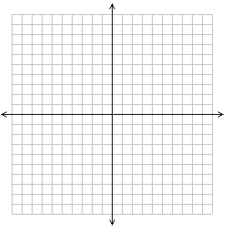
Resistance

