Matching the Motion Activity Handout

Preliminary Questions
- Sketch the following proposed situations on the given coordinate system. The x-axis is time (s) and the y-axis is distance (m).
- An object at rest

- An object that is moving in the positive direction with a constant speed.

- An object that is moving in the negative direction with a constant speed.

- What would graphs b and c look like if they were on a velocity vs. time graph instead of a distance vs. time graph?

Experimental Set-Up for the Motion Detector and the Calculator
(CBL set-up from Vernier’s Graph Matching lab)
http://www.vernier.com/cmat/pwv.html

- Place the Motion Detector so that it points toward an open space at least 4 m long. Use short strips of masking tape on the floor to mark the origin and the 1 m, 2 m, and 3 m distances from the Motion Detector.
- Connect the Vernier Motion Detector to the SONIC port of the CBL unit or the DIG/SONIC 1 port of the LabPro unit. Use the black link cable to connect the CBL/LABPRO unit to the calculator. Firmly press in the cable ends.
- Set up the calculator and CBL/LabPro for the Motion Detector. Start the PHYSICS program and proceed to the MAIN MENU.
- Select SET UP PROBES from the MAIN MENU.
- Select ONE as the number of probes.
- Select MOTION from the SELECT PROBE menu.

- Set up the calculator and CBL/LabPro for data collection.
- Select COLLECT DATA from the MAIN MENU.
- Select TIME GRAPH from the DATA COLLECTION menu.
- Enter “0.1” as the time between samples, in seconds.
- Enter “99” as the number of samples (the CBL/LabPro will collect data for about 10 seconds).
- Press , then select USE TIME SETUP to continue. If you want to change the sample time or sample number, select MODIFY SETUP instead.
- Select LIVE DISP from the TIME GRAPH menu.
- Enter “0” for the Ymin, so that the y-axis will start at zero meters.
- Enter “2.5” for the Ymax, so that the y-axis will end at 2.5 meters.
- Enter “0.5” for Yscl, so that the y-axis will have a tick mark every half meter.

Graph Matching
-Use the information given, either the equation or graph, and attempt to match the graph shown with the output on the calculator from the motion detector. Be sure to show the instructor if you have a match and they will initial your worksheet.

- y=3x

- y=2x-3
(for y greater than or equal to zero, if y is less than zero- it will just show up on the calculator as zero because the sensor can only read one direction)

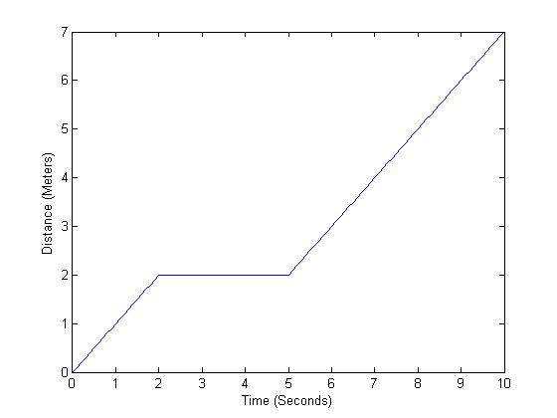
- Attempt to match the piecewise graph above. Find the slope of each part of the line and write equations of each different part of the line. Be sure to have the instructor initial your paper after you

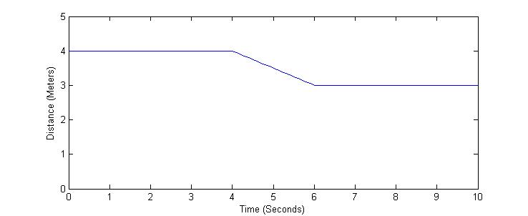
- Attempt to match the piecewise graph above. Find the slope of each part of the line and write equations of each different part of the line. Be sure to have the instructor initial your paper after you

