Matching the Motion Handout/Worksheet

Preliminary Questions
- Sketch the following proposed situations on the given coordinate system. The x-axis is distance (m) and the y-axis is distance (m).
- An object at rest

- An object that is moving in the positive direction with a constant speed.

- An object that is moving in the negative direction with a constant speed.

- What would graphs b and c look like if they were on a velocity vs. time graph instead of a distance vs. time graph?
(See the Blue arrows for these solutions)
Graph Matching
-Use the information given, either the equation or graph, and attempt to match the graph shown with the output on the calculator from the motion detector. Be sure to show the instructor if you have a match and they will initial your worksheet.

- y=3x

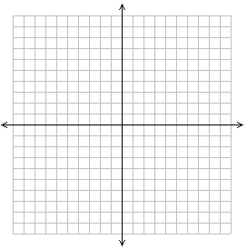

- y=2x-3
(for y greater than or equal to zero, if y is less than zero- it will just show up on the calculator as zero because the sensor can only read one direction)

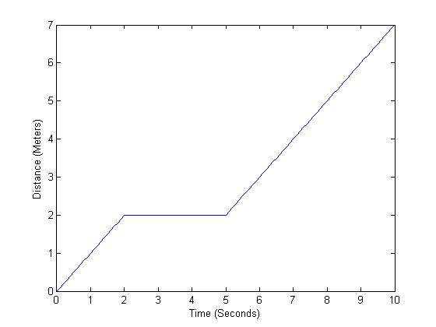
- Attempt to match the piecewise graph above. Find the slope of each part of the line and write equations of each different part of the line. Be sure to have the instructor initial your paper after you

Part 1: m=1, y=x

Part 2: m=0, y=2

Part 3: m=1, y=x-3

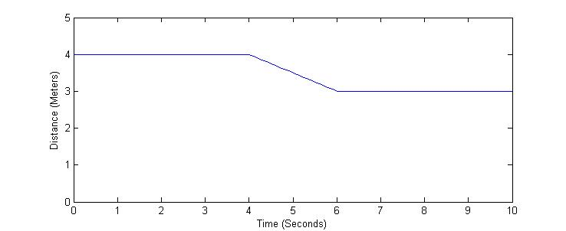
- Attempt to match the piecewise graph above. Find the slope of each part of the line and write equations of each different part of the line. Be sure to have the instructor initial your paper after you

Part 1: m=0, y=4

Part 2: m= -0.5, y= -0.5x+6

Part 3: m=0, y=3

