Screen Captures of Spectrometer Images
Below are three screen captures of wavelength vs. percent reflectance graphs. They are examples of the interference pattern produced when a reflectance measurement of a porous silicon film is taken.
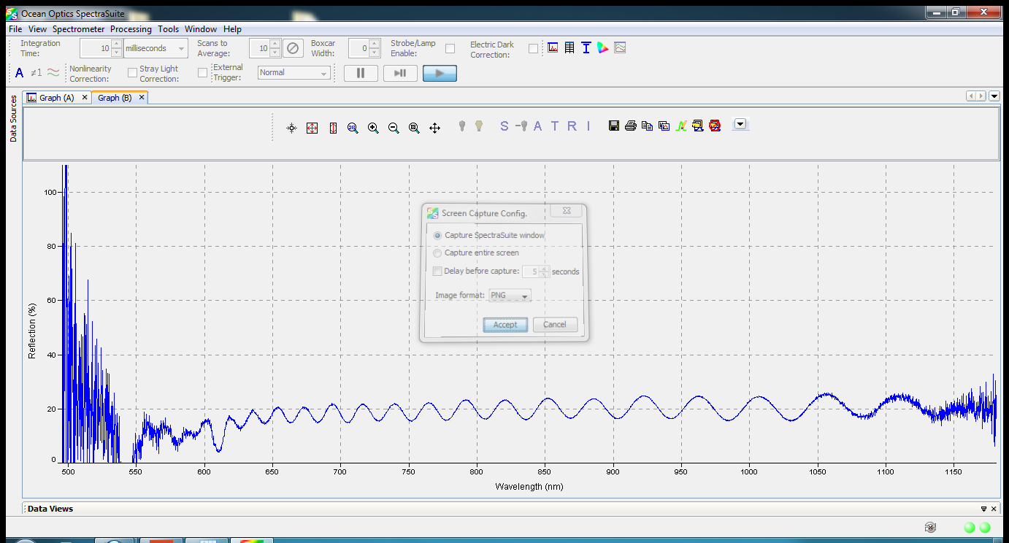

Figure 1

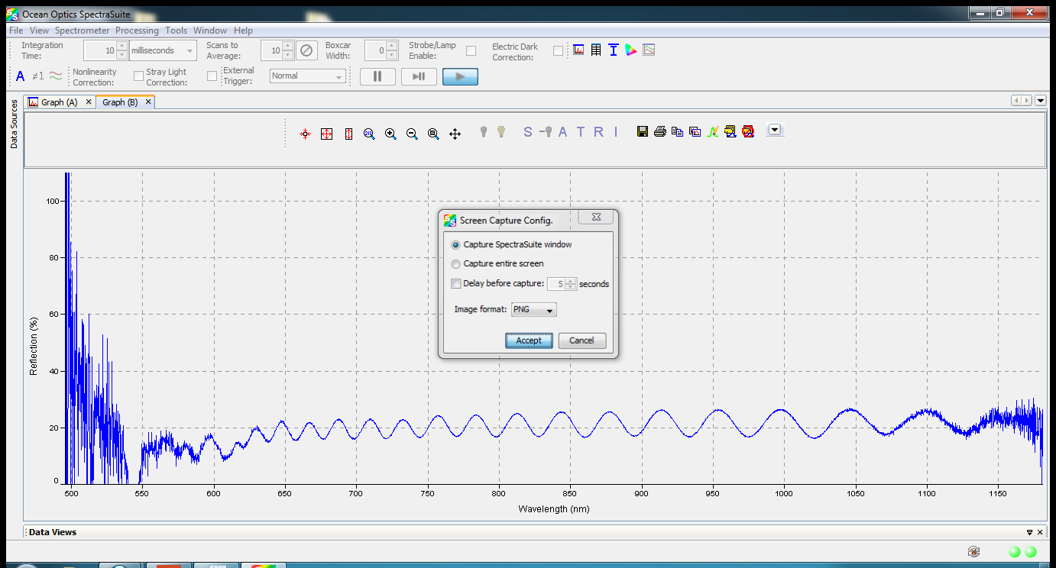

Figure 2

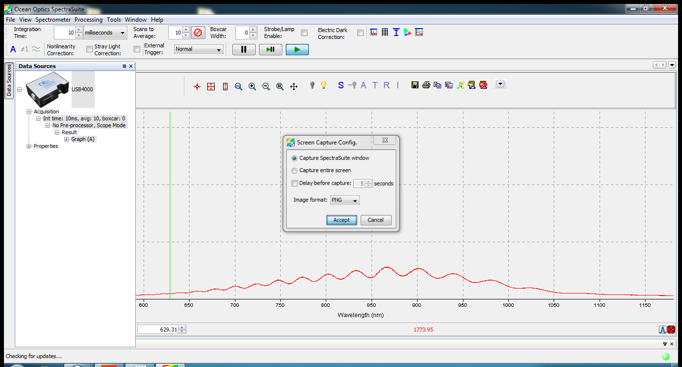

Figure 3

Images source: 2013 Caleb Swartz, Vanderbilt University

