What have you learned today?
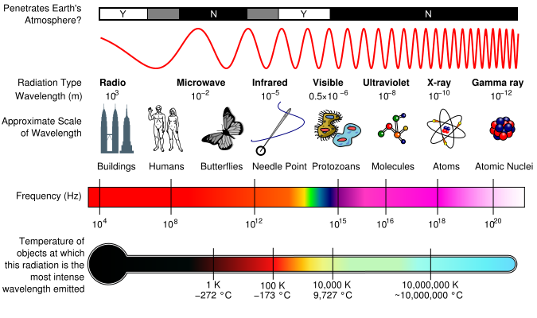
- On the image to the left, circle where you would expect the light from a flashlight to appear.

- What type of radiation does this represent?

- What word is used to describe an object that reflects 100% of the incident light?

- Rainbows often appear during light rainfall when the sun is out. Why is this?
What two things must be present in the atmosphere? What is happening to the sunlight?

- What would you expect to happen if a beam of light was directed straight towards you?

- Considering your answer above, how can we protect the troll?

- Can you think of any action movie scenes that apply these concepts?

- Describe any other uses for radiation that can penetrate the human body.

- What are some safety concerns to consider when working with different types of radiation?

- Do you have any unanswered questions about the light properties you explored today?
What additional objects are you are interested in exploring?

