Sonoran Desert / Ecology Test
I. Visuals (16 pts)

1a._______________________ What type of flight adaptation is this?

b.________________________Name the bird pictured.

2. _______________________What resource is this species adapted to conserve?

3a.________________________What type of flight adaptation does this species have?

b.________________________How do its flight feathers differ from other birds?

4.________________________What adaptation is shown by this animal?

5a.________________________List 2 ways these animals’ niches reduce overlap.

b.________________________

6.________________________What flight pattern does this aircraft mimic?

7a.________________________Name the biome where this plant lives.

b._________________________Name the group this plant belongs to.

8._________________________Identify the role these species play within their communities.

9._________________________What aspect of biomimicry was discussed with this feather?

10.________________________Name a limiting factor that was the cause of this bird’s decline.

11a._______________________Name the organism the arrow is pointed at.

b.________________________Name the relationship it has with the Saguaro.

II.__Multiple Choice (1 point each)___
___1. Which is true about carrying capacity?
- Carrying capacity can raise or lower depending on limiting factor availability
- Carrying capacity is fixed and never changes
- Carrying capacity determines population density
- Carrying capacity determines the amount of limiting factor
- a & c g. b & c
f. a & d h. b & d
___2. Photosynthesizing organisms are referred to as:
a. consumers b. heterotrophs c. omnivores d. autotrophs
___3. A generalist’s niche is ___ than a specialist’s and makes it __likely to be threatened.
a. wider, more c. narrower, more
b. wider, less d. narrower, less
___4. Which is not an abiotic part of the environment?
a. decomposer b. sunlight c. water d. soil
___5. The greatest number of individuals that a space can support indefinitely without
degrading the environment is called:
a. carrying capacity b. limiting factor c. density d. homeostasis
___6.What two factors cause population density to decrease?
a. emigration and mortality c. emigration and natality
b. immigration and mortality d. immigration and natality
___7. Which biome has a wet, mild winter and a hot, dry summer?
a. desert b. chapparal c. grasslands d. taiga
___8. What conclusion can be drawn from the observation that both downy and pileated woodpeckers are observed at Radnor Lake?
- each species niche is identical to the other
- each species niche is 100% different to the other
- slight niche overlap is expected
- no conclusion can be drawn
___9. The feathers of a bird’s wing form a continuous surface due to the interlocking ______:
a. vane and barbs b. vane and barbules c. shaft and vane d. barb and barbules
___10. The biome with the richest, most fertile soil is the:
a. rainforest b. grasslands c. deciduous forest d. chapparal
___11. Nicotine is a chemical extract produced by _______ to protect against ________.
a. tobacco, herbivores c. milkweed plants, monarch butterflies
b. cocoa beans, carnivores d. caterpillars, predation
___12. As one moves east away from the Rocky Mountains, rainfall ____ and grasses are ____
a. increases, taller c. decreases, taller
b. increases, shorter d. decreases, shorter
___13. Which is not a part of the biosphere?
a. oxygenated atmosphere b. earth’s rock mantle c. species d. soil e. water ___14. The stability of a community generally increases with a:
a. greater diversity of organisms and more links in the food web
b. greater diversity of organisms and fewer links in the food web
c. lower diversity of organisms and fewer links in the food web
d. lower diversity of organisms and more links in the food web
___15. Which best represents carrying capacity for an environment?
a. sum of its limiting factors c. biotic components
b. abiotic components d. population density
___16. Which does not restrict population growth?
a. predators b. disease c. natality rate d. competition
___17. How does carrying capacity differ between coyotes and rabbits?
a. both exist at the same density c. coyotes always have a higher density
b. rabbits always have a higher density d. both respond to the same limiting factors
___18. Flight occurs as _____pressure above a bird’s wing and ____ pressure beneath causes lift :
a. high, low c. high, high
b. low, high d. low, low
___19. A limiting factor can be:
a. abiotic c. positive e. all of the above
b. biotic d. negative
___20. Which is not an example of biomimicry and its study?
a. camouflaged arctic fox c. wetland based water purification
b. termite mound ventilation d. structural color of butterfly wings

III. PROBLEMS, GRAPHS AND TABLES
1. Growth Rate Curves (8 pts)

a

- - - - - - - - - - - - - - - - - - - - - - - - - #1 - - - - - - - - - - - - - - - - - - - - - - - -#1

Hand drawn on Teacher Key

A B

IDENTIFY CURVES: A.______________________ B.________________________

What does #1 represent on each graph? ____________________________________________

What does “a” represent in graph A?____________________________________________

Explain in 1 sentence why the line drops quickly in Growth Rate Curve A

List 2 examples of species that follow the pattern shown in Graph A.

--------------------------------------------------------------------------------------------------------------

2. Graph the following data, label each axis with all necessary information. Next, draw a line on the graph to indicate where carrying capacity is. (5 pts)


Date | Deer  Density
1983 | 14
1984 | 19
1985 | 26
1986 | 34
1987 | 38
1988 | 46
1989 | 44
1990 | 45
1991 | 46
1992 | 47
1993 | 45

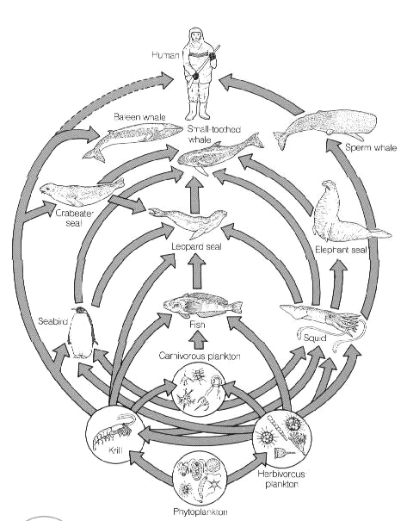

3.

: A

a. Diagram a 4 species food chain from the above food web.

b. List all of the food resources shown for the small toothed whale.

4. Compare the two graphs below. CIRCLE which graph represents two species successful in occupying the same habitat and explain why they are successful compared to the unsuccessful graph. (2-3 sentences) (4 pts)

Hand drawn on Teacher Key

A B

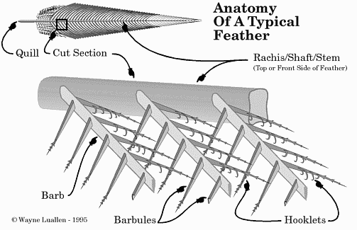

A
B
B

(4pts)
5. Identify A:______________________ B:___________________________

Explain what their function is to the wing of a bird.

6. Look at this typical predator-prey cycle. Label which is the predator curve and which is the prey curve. (7 pts)

Pop #
Hand drawn on Teacher Key

Time
LIST 3 “rules” that apply to a predator-prey relationship:

a. ___________________________________ c.____________________________

b.___________________________________
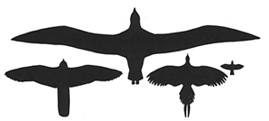
A
B
D
C

(4 pts)
7. Identify the silhouette that shows a bird with high flight speeds:_______

Identify the silhouette that shows a bird with a gliding flight pattern:______

8. List 3 adaptations plants have evolved to defend themselves against herbivores. (6 pts)

a._______________________________ b.______________________________

c.______________________________

9. List 3 vital functions that wetlands serve that would economically benefit humans and demonstrates the need to protect these areas. (6 pts)

__________________________________________ ________________________________

__________________________________________

10. List the 3 biomes located at mid-latitudes.(3 pts)

_______________________ _______________________ _________________________

11. List 3 adaptations that aeronautical engineers have biomimicked AND identify the bird with this adaptive trait. (6 pts)

Adaptation Bird

______________________________________________ __________________

______________________________________________ __________________

______________________________________________ __________________

Short answer: Responses should be 3 – 5 sentences in length. (5 pts)

1. Explain the benefits of studying and understanding aspects of biomimicry. Provide 2 examples from the “12 Patterns of Biomimicry”.

You may choose to only offer one of the two short answer responses given here.

2. Explain the relationships that the white-winged dove has to the following species and how the dove affects the population densities of the other species listed: (7 pts)
Harris antelope ground squirrel Harris Hawk Saguaro

EXTRA CREDIT **3 POINTS EACH**

1. Explain how a prairie cycles to maintain this biome. Include both biotic and abiotic components.

2. Is the honeybee suited to the study and benefits of biomimicry? Explain.

