Legacy Cycle for Bone Mineral Density and Logarithms Module

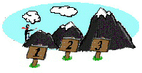
Grand Challenge. "You work for a company that manufactures cabinet X-ray systems used in imaging small specimens. You want to sell more systems, so you need to find a way to make your current system more marketable by showing that your system is capable of performing multiple functions. One function you want to investigate is if your current system is capable of producing bone mineral density (BMD) images. If it is, you believe that you can increase your sales dramatically. You hire a team of biomedical engineers to research your product's applications to BMD. After many hours of research, the team has presented the following image to you. Is this an acceptable image? How do you know?"

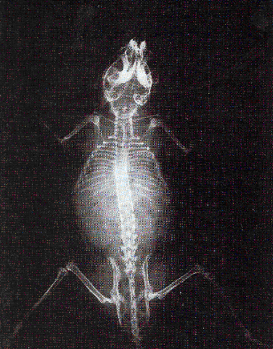

Figure 1. Bone Mineral Density Grand Challenge Image

Generate Ideas: (1) What are your initial ideas about how these questions can be answered? (2) What background knowledge is needed? (3) What do you know about X-rays already? (4) What do you know about bone mineral density already?

