Name____________________________________ Date_____________ Period____________

Magnetic Field Check

- Describe the magnetic field of a permanent magnet.

- Which of the following materials is NOT magnetic?
(A) Iron (B) Aluminum (C) Steel (D) Nickel

- Which picture correctly shows the magnetic field around the magnet?
(A) 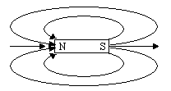 (C)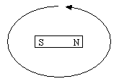
(B) 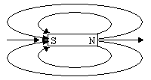 (D)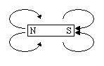

- Which arrow correctly shows the direction of the magnetic field at X?
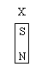
(A) (C)

(B) (D)

- Describe the magnetic field of an electrical current.

- Which of the following situations will produce a magnetic field?
  - A wire is not connected to a battery and carries no current.
  - A wire is connected to a battery but a switch is open so there is no current flow.
  - A wire is connected so that current flows from the negative to the positive terminal of the battery.
  - A compass is placed next to a wire.

- Which picture correctly shows the magnetic field around the wire (the circle) if the current is coming up out of the paper?
  - 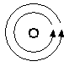 (C) 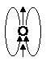
  - 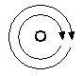 (D) 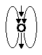

- Which arrow correctly shows the direction of the magnetic field at X if a wire goes through the page at the circle and current flows down into the paper?


(A) (C)

(B) (D)

