Key for Clean Up This Mess Quiz
10 points each question.

- Only iron, steel, and nickel should be circled. One point for each incorrectly marked substance.

- D

- 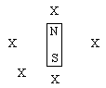 2 points for each correct arrow.

- A
- 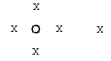 2 points for each correct arrow.

- B

- 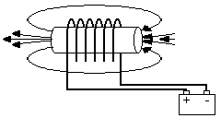 5 points for each correct pole
N S

- C

- D

- A

