Name____________________________________ Date_____________ Period____________

Clean Up This Mess Quiz

Magnetism: Describe the magnetic field of an electromagnet.
- Circle the following items that are affected by a magnetic field.

Wood Aluminum Gold Plastic
Brass Steel Silver
Iron Nickel Lead

- Which picture correctly shows the magnetic field around the magnet?
(A) 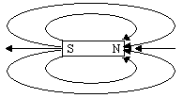 (C)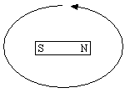

- 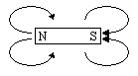 (D)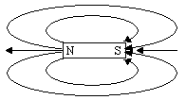

- Draw arrows to show the direction of the magnetic field at the Xs around the magnet.

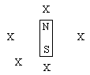

- Which picture correctly shows the magnetic field around the wire (the circle) if the current is coming up out of the paper?
  - 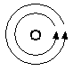 (C) 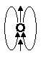
  - 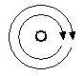 (D) 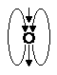

- Draw arrows to show the direction of the magnetic field at the Xs around the wire if the current in the wire is coming up out of the paper.
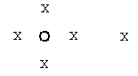

- Which of the following best describes an electromagnet?
  - It is a magnet that produces electricity.
  - It is a magnet produced by the magnetic fields of an electric current.
  - It is a magnet that produces electric fields.
  - It is electricity that has a magnetic field.

- In the picture below, label the North and South poles of the electromagnet.

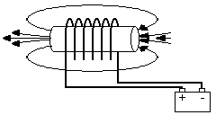
- Which of the following actions will make an electromagnet stronger?
  - Wrap the wire carrying the current around a pencil.
  - Make fewer loops with the wire carrying the current.
  - Make more loops with the wire carrying the current.
  - Decrease the current through the wire.

- Which electromagnet is strongest?
(A) 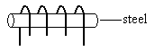 (C)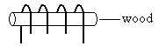
(B) 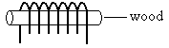 (D)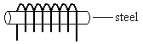

- A magnet is positioned next to an electromagnet as shown. The current in the electromagnet is then reversed. What will happen?

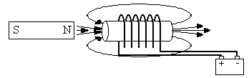

  - The magnet and electromagnet will repel each other.
  - The magnet and electromagnet will attract each other.
  - The magnet and electromagnet will cancel each other’s fields.
  - Nothing different will happen.

