Conservation of Energy Quiz
Answer Section

SHORT ANSWER

1. elastic potential energy

2. Kinetic energy is a scalar quantity.

3. At the top of the fall, all the energy is gravitational potential energy. During the fall, gravitational potential energy decreases as it is transformed into kinetic energy. When the pencil reaches the ground, all the energy is kinetic energy.
4. elastic potential energy

5. The potential energy decreases.

6. It will be less than 1.2 × 10 J. Because friction is not negligible, mechanical energy is not conserved, and some mechanical energy will be lost.

PROBLEM

7. Given
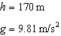

Solution
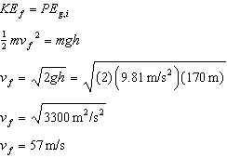

8. Given
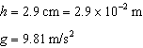

Solution
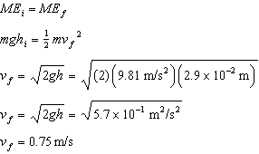

ESSAY

9. It is true that the book loses potential energy throughout its fall and loses all of its kinetic energy when it reaches the floor. However, this energy is not destroyed. Instead, it is converted into heat and sound. The law of conservation of energy is still correct.

10. The roller coaster gains gravitational potential energy by climbing the hill (usually with the help of a chain or some other lifting device). It has essentially no kinetic energy at the top of this hill, so all its mechanical energy is stored as gravitational potential energy. If another hill were higher, the roller coaster would not be able to reach this higher hill, even if no energy was lost during the ride.

