Interpreting Graphs Worksheet

1. Given the graph below, answer the following questions:
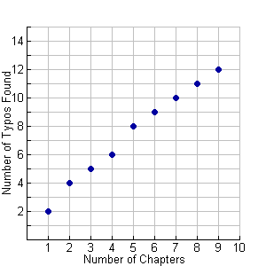

- What is the independent variable for this graph?

- What is the dependent variable for this graph?

- What can you assume about the relationship between number of chapters in a book and the amount of typos found?

- About how many typos would you assume to be in a book with 10 chapters?

2. Given the graph below, answer the following questions:
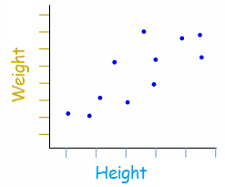

- What is the independent variable for this graph?

- What is the dependent variable for this graph?

- Write a two-sentence explanation for what the graph is attempting to describe.

- Assume that the increments for weight are 20 pounds, starting with 50 pounds, and the height increment is by 5 inches, starting with 50 inches. What would you expect a person to weigh if s/he was 80 inches tall?

- Draw a line on the graph that you believe represents the best fit for weight and height.

3. The graph below shows the relationship between students’ quiz averages over a semester and their final exam grades.

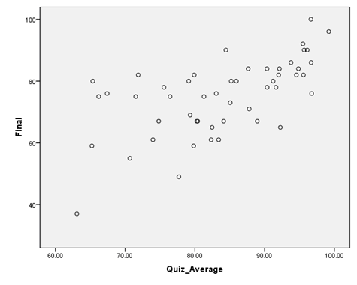

- What is the independent variable for this graph?

- What is the dependent variable for this graph?

- Write a two-sentence explanation for what the trend of the line is showing, given the two variables.

- Provide at least three data points on the graph.

- With a straight line, connect the data point at the far left with the data point at the top right. Does this line best represent the data? Explain.

