Name:_______________________________
Coordinate Plane, Functions, Domain and Range Homework
- In what quadrant are the following points located.
- (-6,3) ______________________
- (7,-10) ______________________
- (-4,-4) ______________________
- (-18,5) ______________________

- Determine whether each of the relations below are a function or not. Then, using proper set notation, state the domain and range. If necessary, draw a mapping diagram on the back side of this sheet of paper.
- {(1,9), (8,1), (7,5), (8,5)} B) {(a,a), (b,a), (c,a), (d,a)}
Function? Function?

Domain: Domain:

Range: Range:

- {(1,2), (3,4), (5,6), (7,8), (9,13)} D) {(7,1), (10,7), (0,8), (2,17), (7,3)}
Function? Function?

Domain: Domain:

Range: Range:

- {(1,1), (1/2, 2), (1/3, 3), (1/4, 4)} F) {(4,2), (9,3), (4,-2), (9,-3)}
Function? Function?

Domain: Domain:

Range: Range:

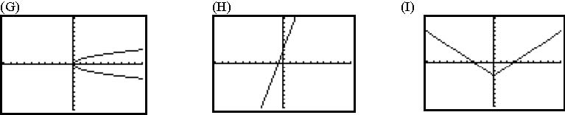 Function? Function? Function?
Domain: Domain: Domain:
Range: Range: Range:

