Name:________KEY____________________
Coordinate Plane, Functions, Domain and Range Homework
- In what quadrant are the following points located.
- (-6,3) ________Q II______________
- (7,-10) ________Q IV_____________
- (-4,-4) ________Q III______________
- (-18,5) ________Q I_______________

- Determine whether each of the relations below are a function or not. Then, using proper set notation, state the domain and range. If necessary, draw a mapping diagram on the back side of this sheet of paper.

- {(1,9), (8,1), (7,5), (8,5)} B) {(a,a), (b,a), (c,a), (d,a)}
Function? No. Function? Yes.

Domain: {1,7,8} Domain: {a,b,c,d}

Range: {1,5,9} Range: {a}

- {(1,2), (3,4), (5,6), (7,8), (9,13)} D) {(7,1), (10,7), (0,8), (2,17), (7,3)}
Function? Yes. Function? No.

Domain: {1,3,5,7,9} Domain: {0,2,7,10}

Range: {2,4,6,8,13} Range: {1,3,7,8,17}

- {(1,1), (1/2, 2), (1/3, 3), (1/4, 4)} F) {(4,2), (9,3), (4,-2), (9,-3)}
Function? Yes. Function? No.

Domain: {1,1/2,1/3,1/4} Domain: {4,9}

Range: {1,2,3,4} Range: {-2,-3,2,3}

Continue on to the next page to see the graphs.

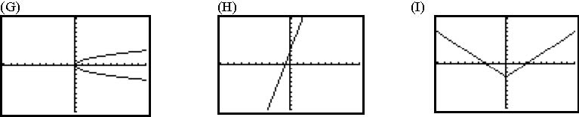
Function? No. Function? Yes. Function? Yes.
Domain: {x| x≥0} Domain: {x|x ε R} Domain: {x|x ε R}
Range: {y|y ε R} Range: {y|y ε R} Range: {y|y ≥ -3}

