Name: _______________________________

Slope Homework

- Find the slope of the lines graphed below. Assume the x- and y-axes count by 1’s.
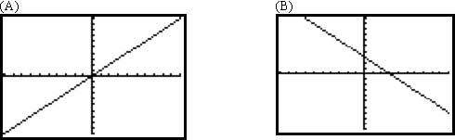

(C) (D)
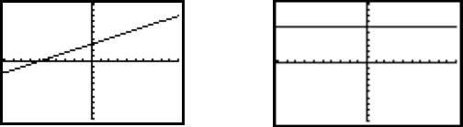

- Find the slope given the rise and run.
(A) Rise: -6  Run: 3  Slope: | (B) Rise: 3  Run: 10  Slope:
(C) Rise: -9  Run: -5  Slope: | (D) Rise: -1  Run: 7  Slope:

- Find the slope given the two points.
(A) (23, 1) & (2, 6) | (B) (2, 7) & (0,0)
(C) (8,10) & (8,7) | (D) (10,4) & (7,4)

- Find the parallel and perpendicular slopes based on the given information.
(A) Rise: 4  Run: 8  Parallel slope:  Perpendicular slope: | (B) (-3,2) & (2,3)  Parallel slope:  Perpendicular slope:

