Name: KEY _

Slope Homework

- Find the slope of the lines graphed below. Assume the x- and y-axes count by 1’s.
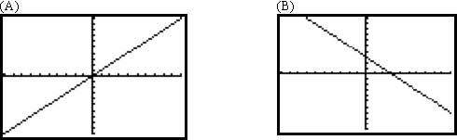
M=(Δy/Δx)=(1/1)=1 M=(Δy/Δx)=(-1/1)=-1

(C) (D)
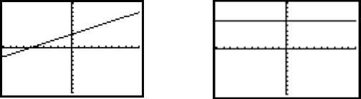
M=(Δy/Δx)=(1/2) M=(Δy/Δx)=(0/1)=0

- Find the slope given the rise and run.
(A) Rise: -6  Run: 3  Slope: M=(Δy/Δx)=(-6/3)=-2 | (B) Rise: 3  Run: 10  Slope: M=(Δy/Δx)=(3/10)
(C) Rise: -9  Run: -5  Slope: M=(Δy/Δx)=(-9/-5)=(9/5) | (D) Rise: -1  Run: 7  Slope: M=(Δy/Δx)=(-1/7)

- Find the slope given the two points.
(A) (23, 1) & (2, 6)  M= (y₂-y₁)/(x₂-x₁)=(6-1)/(2-23)=5/-21 | (B) (2, 7) & (0,0)  M= (y₂-y₁)/(x₂-x₁)=(7-0)/(2-0)=7/2
(C) (8,10) & (8,7)  M= (y₂-y₁)/(x₂-x₁)=(10-7)/(8-8)=3/0  (undefined- vertical line) | (D) (10,4) & (7,4)  M= (y₂-y₁)/(x₂-x₁)=(4-4)/(10-7)=0/3=0  (horizontal line)

- Find the parallel and perpendicular slopes based on the given information.
(A) Rise: 4  Run: 8  Parallel slope:  M=(Δy/Δx)=4/8=1/2  Perpendicular slope: -2 | (B) (-3,2) & (2,3)  Parallel slope:  M=(Δy/Δx)=(3-2)/(2+3)=1/5  Perpendicular slope: -5

