Forms of Lines
- Slope-intercept Form
M is the slope, while y is the y-intercept

Step 1: Plot the y-intercept on the coordinate Plane.
Step 2: Count the slope from that point.
Step 3: Connect the dots.

Ex.
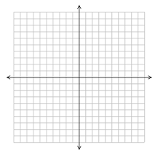
Special Case: Direct Variation (where b=0)
This only occurs when the y-intercept is the origin (0,0).

- Standard Form
Step 1: Find the x- and y- intercepts
Step 2: Plot and Connect
Ex.
X | Y
0 | 3
4 | 0

- Point-Slope Form
M is the slope.
x₁ and y₁ are coordinates of a point given on the graph.
Step 1: Plot the point (x₁,y₁)
Step 2: Count the slope.
Step 3: Connect the dots.
Ex.

