Name: ___KEY_________________________

Point-Slope Form Homework

- Write an equation in point-slope form for the line with the given information.
(A) slope of 2; (3, 4) | (B) slope of -2; (-3, 4)
(C) slope of 3; (2, 6) | (D) slope of 1/5; (-4, -2)
(E) (5, -2) and (-2, 5)  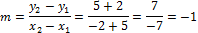 | (F) (-3, 3) and (-4, 4)  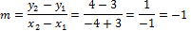

- Graph the following equations on the given coordinate plane.
(A) | (B)
(C)  y-axis  (C) | (D)
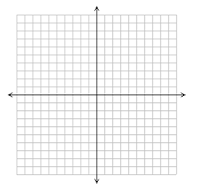
x-axis
(D)
(B)
(A)

