Name: _______________________________

Slope-Intercept Form Homework

- Identify the slope, x-intercept, and y-intercept for each of the following equations. Then graph and label them on the provided coordinate plane.
(A)  m: x-int: y-int (b): | (B)  m: x-int: y-int (b):
(C)  m: 4 x-int: y-int (b): | (D)  m: x-int: y-int (b):

(A)
(C)
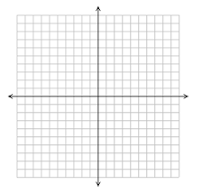
(D)
(B)
- Write an equation in slope-intercept form for the line that contains the following points.
(A) (0,6) and (5,0)  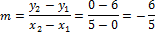 | (B) (3,4) and (-1,-2)  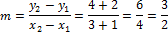
(C) (7,-7) and (-4,-3)  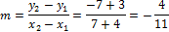 | (D) (6,6) and (-2,-2)  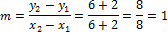

- Write an equation in slope-intercept form for the line that fits each description below.
(A) contains the origin and has a slope of -2 | (B) crosses the y-axis at -1 and has a slope of 5
(C) contains (-3,2) and (6,6)  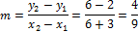 | (D) contains the point (3,-5) and is parallel to the line
(E) contains the point (-1,4) and is parallel to the line | (F) contains the point (2,7) and is perpendicular to the line

