Name: ___KEY_________________________

Standard Form Homework

- Write each of the following equations in standard form.
(A)  -3x+y=7 | (B)  -3x+2y+-4
(C)  y-50=8x-32  -18=8x-y  8x-y=-18 | (D)  6x-2y=14
(E)  4x+14y=-10 | (F)  x+9y=-15

- Find the x-and y-intercepts and use them to graph each equation.
(A) | (B)
  x | y
  0 | 10
  10 | 0
  x | y
  0 | -6
  4 | 0
(C)  y-axis (by 2)  A) | (D)  B)
  x | y
  0 | 18
  2 | 0
  x | y
  0 | -2
  7 | 0
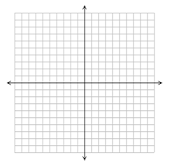
x-axis (by 2)
D)
C)

