End-of-Unit Test Name: ____KEY__________________

- Find the equation of the line parallel to $7x−6y=\text{13}$that passes through the point (-42, -51). Express your answer in Slope-Intercept Form. Show your work!

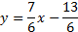
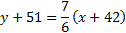
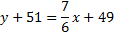
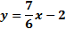

- Find the equation of the line perpendicular to $3x+8y=−\text{15}$ that passes through (-9, 14). Express your answer in Point-Slope Form. Show your work!

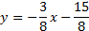
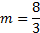
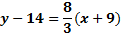

- Find the equation of the line parallel to the line $y=6$ that passes through (-5, 2).

- Find the equation of the line perpendicular to the line $y=−1$that passes though (7, 3).

- Determine whether each of the relations below is a function and then, using proper set notation, state its domain and range.

(A) {(1, 7), (2, 5), (4, 5), (6, 6)}  Function  Domain: {1,2,4,6}  Range: {7,5,6} | (B) {( , ), ( , ), ( , )}  Not a Funciton  Domain: {}  Range: {} | (C) {(2, 8), (3, 10), (2, 5), (6, 17)}  Not a Function  Domain: {2,3,6}  Range: {8,10,5,17}

- y varies directly as x. If y is 30 when x is 0.6, ...

- find the constant of direct variation, k. Show some work!  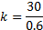 | - write an equation of direct variation in the form y = kx. | - find y when x is 20. Show your work!

- Show your work as you find the slope of the line that passes through the following points:

- (8, -13) and (2, -6)  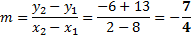 | - (9, 6) and (-5, 3)  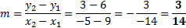
- Determine whether each statement is true or false. Write the entire word, not simply “T” or “F”.

_____F______When read from left to right, a line with a positive slope will be decreasing.

_____T______ The slope of any horizontal line is zero.

_____F______ It is impossible for the slope of a line to be undefined.

_____F______ When read from left to right, the line increases more quickly than the line .

- Match each term with its correct formula.

__(D)__ Slope-Intercept Form (A)

__(C)___ Vertical Line (B)

__(E)___ Standard Form (C)

__(B)___ Point-Slope Form (D)

__(A)___ Horizontal Line (E)

- Write the equation of the line (in Slope-Intercept Form) that passes through the points (8, -3) and (16, 4). Show your work!

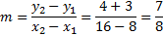
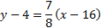
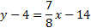
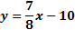

- Write the equation of the line (in Point-Slope Form) that passes through the points (-4, -3) and (-8, -9). Show your work!

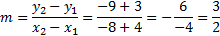
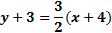

- Find the x and y intercepts of the line . Show your work! You can express your final answer as either a single number or an ordered pair.

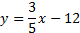
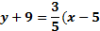

x – intercept: y – intercept:

- Convert the equation from Point-Slope Form to Slope-Intercept Form. Show your work!

- Using the rectangular coordinate system below, graph each of the linear equations. Write each equation beside its corresponding graph.

