Optical Biosensor for Continuous Rapid Detection of Health Threats
Posted by Jan Sinnige | September 7, 2011 | Medgadget.com | http://www.medgadget.com
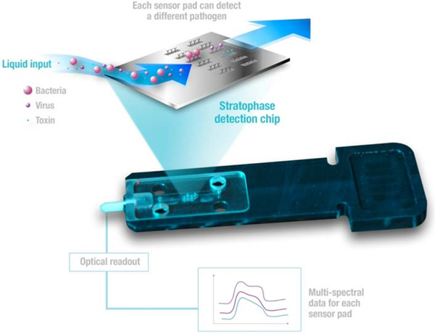

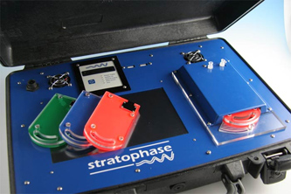
Researchers from Stratophase, a firm out of Southampton, UK, just published a paper in journal Biosensors and Bioelectronics, describing the technology inside their SpectroSens chip, a new optical micro device designed to rapidly detect pathogens and biochemicals. The chip can be loaded into a robust device to simultaneously identify 16 different potential health threats like anthrax and ricin toxin.
The chip works with light that reflects in different wavelengths in different situations. The reflectors, which are called Bragg gratings, will reflect one wavelength and let all other wavelengths pass through unaffected. The specific color it reflects can be correlated with a location on the chip. Interactions between target antigens in the test sample and respective immobilized antibodies on the chip result in localized changes in the refractive-index. This increases the wavelength of the reflected light which can be detected. With one chip it is possible to multiplex 16 different biological agents like spores, viruses and toxins in real-time. You can either load samples manually or, when continuous monitoring is necessary, the cartridge can be combined with air sampling technology.
The company tested the device first on harmless biological agents like Bacillus atrophaeus(BG) spores, Escherichia coli cells, MS2 viruses and albumin protein. Thereafter, they tested the method on organisms like Bacillus anthracis (BA) spores, Vaccinia viruses (heat-killed) and ricin toxin. The soluble protein antigens seem to give a higher and earlier response than the larger bacterial and viral antigens, but in the end all were picked up by the detector.
The disposable microchips and robust device are compact and easy to transport, which makes them ideal to do rapid on-site monitoring. The system can be used in security and defense operations, but also in regular in-field medical diagnostics for human and veterinary health.
—o0o—
Source: Sinnige, Jan. MedGadget. “Optical Biosensor for Continuous Rapid Detection of Health Threats.” Posted September 7, 2011. Medgadget Journal of Medical Technology. Accessed June 24, 2013. http://www.medgadget.com/2011/09/optical-biosensor-for-continuous-rapid-detection-of-health-threats.html
Abstract in Biosensors and Bioelectronics: Optical microchip array biosensor for multiplexed detection of bio-hazardous agents ^{[3]}
Stratophase’s optical microchip technology ^{[4]} info page…

Jan Sinnige ^{[9]} Resident Medical Microbiology, MD at UMC Utrecht, The Netherlands. PhD Candidate in molecular epidemiology of Vancomycin Resistant Enterococcus faecium (VRE). Living in Amsterdam.

@jsinnige ^{[10]}Follow @jsinnige ^{[11]}
URLs in this post:
[1] Tweet: http://twitter.com/share
[2] Image: http://www.medgadget.comjavascript:javascript:void((function(){var e=document.createElement(
[3] Optical microchip array biosensor for multiplexed detection of bio-hazardous agents: http://www.sciencedirect.com/science/article/pii/S0956566311005884
[4] Stratophase’s optical microchip technology: http://www.stratophase.com/stories/biothreats.html
[5] Bio: #ts-fab-bio-below-26984
[6] Twitter: #ts-fab-twitter-below-26984
[7] LinkedIn: #ts-fab-linkedin-below-26984
[8] Latest Posts: #ts-fab-latest-posts-below-26984
[9] Jan Sinnige: http://www.medgadget.com/author/jcsinnige
[10] @jsinnige: http://twitter.com/jsinnige
[11] Follow @jsinnige: https://twitter.com/jsinnige
[12] Selfish Memes: Facebook as a Model for Evolution: http://www.medgadget.com/2014/01/selfish-memes-facebook-as-a-model-for-evolution.html
[13] European Society of Cardiology’s Congress 2013: New Announcements from Philips and BIOTRONIK: http://www.medgadget.com/2013/09/esc-congress-2013-new-releases-from-philips-and-biotronik.html
[14] bioMérieux VIDAS 3 Immunoassay Platform Receives CE Mark: http://www.medgadget.com/2013/06/biomerieux-vidas-3-immunoassay-platform-receives-ce-mark.html
[15] GE Healthcare Introduces A New Tumor Typing Platform (VIDEO): http://www.medgadget.com/2013/06/ge-healthcare-introduces-a-new-tumor-typing-platform-video.html
[16] Smartphone-Powered Device for Label-Free Detection of Biological Samples (VIDEO): http://www.medgadget.com/2013/05/smartphone-powered-device-for-label-free-detection-of-biological-samples-video.html
Copyright © Medgadget LLC. All rights reserved.

