How Typeface Influences the Way We Read and Think
And Why Everyone Hates Comic Sans MS
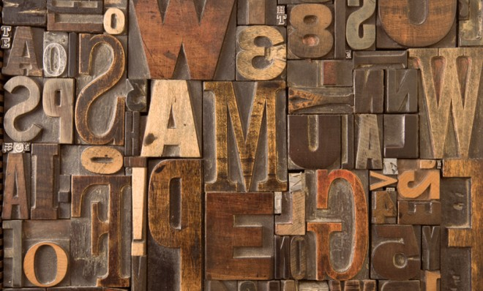
By Chris Gayomali | June 14, 2013

Sometimes fonts speak louder than words.
Thinkstock/iStockphoto

Last summer, CERN* was on the verge of announcing a discovery so critical to understanding the basic building blocks of the universe that it had been given a divine name: The god particle.
The hunt for the Higgs boson was one of the most expensive and labor-intensive particle physics projects ever undertaken, and promised to answer the fundamental but elusive question of why our atoms stick together in the first place. And yet, when CERN researchers finally announced that they'd glimpsed the Higgs, the world's first reaction wasn't to cheer; it was to stifle collective laughter. The institution's scientists, cradling the most important scientific discovery of the decade, had chosen to present their findings to a breathless public using a peculiar font face: Comic Sans MS.
The whole kerfuffle underscored just how important typefaces are to the way we process information. Words hold power. But the aesthetic manner in which those words are presented can affect the way we read, and the way we think about the information presented.
“Typography is one ingredient in a pretty complicated presentation,” Cyrus Highsmith, a typeface designer and author of the book Inside Paragraphs, told me over the phone. “Typography is the detail and the presentation of a story. It represents the voice of an atmosphere, or historical setting of some kind. It can do a lot of things.”

* The European Organization for Nuclear Research, known as CERN is a European research organization and laboratory near Geneva, Switzerland, whose purpose is to operate the world's largest particle physics laboratory.
Source: Guyomali, Chris. “How Typeface Influences the Way We Read and Think.” Published June 14, 2013. The Week. Accessed December 10, 2013. http://theweek.com/article/index/245632/how-typeface-influences-the-way-we-read-and-think

