Light Properties Worksheet
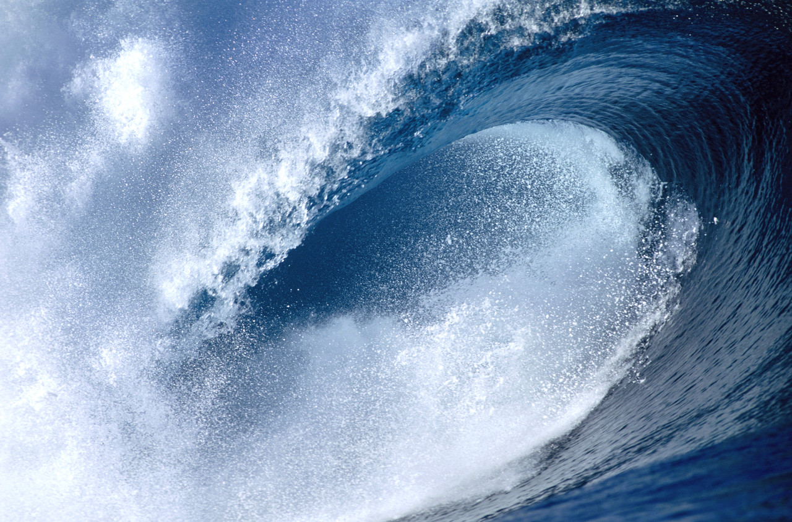
- ____________ travels through water to create waves.
- The energy of light waves is known as ____________________ radiation.
- The picture below represents the electromagnetic ______________________________________.
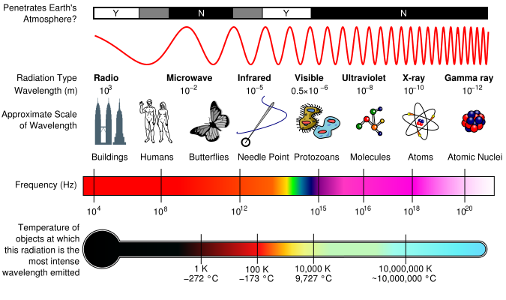

- Young’s two-slit experiment demonstrated the _____________________ theory of light. This theory is known as classic physics.
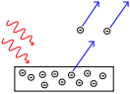
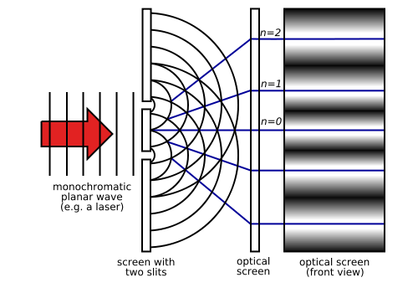

- The photoelectric effect demonstrated the _______________ theory of light. These results are considered the foundation of quantum physics.
- What frequency of light is reflecting off the rocks? ______________
- What is the natural vibrating frequency of the electrons in the rocks? ________________
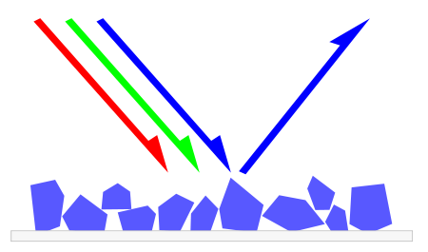
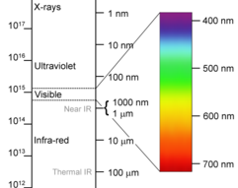

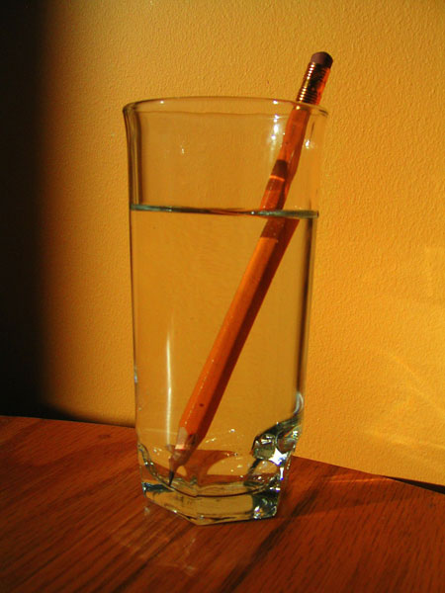
- To the naked eye it looks as if this pencil is __________________,
which demonstrates what property of light? __________________

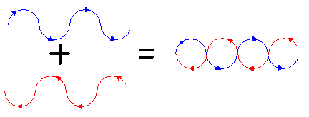
- The image below represents __________________ of the
red and blue waves.

- As the following two waves propagate towards one another, the result will be ______________________ interference.
