Light Properties Worksheet Answers
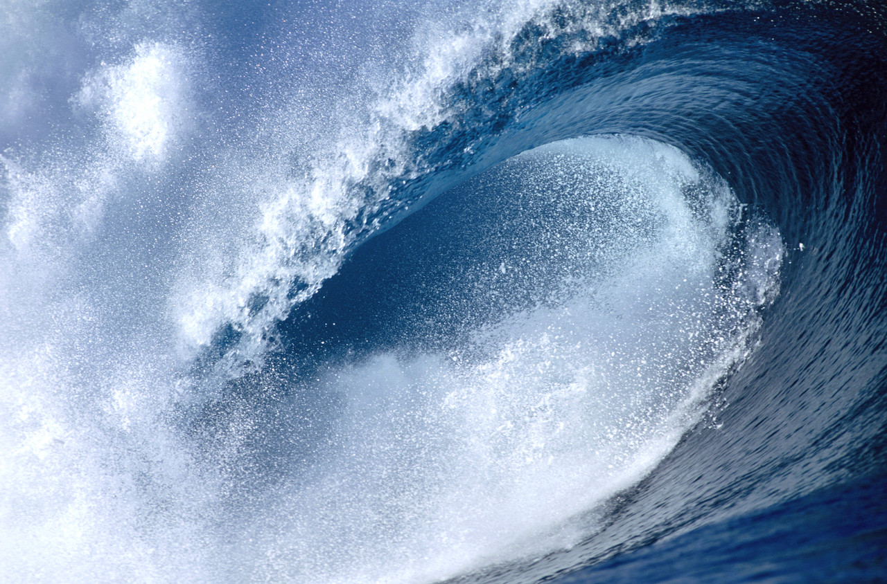
Energy
- ____________ travels through water to create waves.
- The energy of light waves is known as ____________________ radiation.
electromagnetic
- The picture below represents the electromagnetic ______________________________________.
spectrum
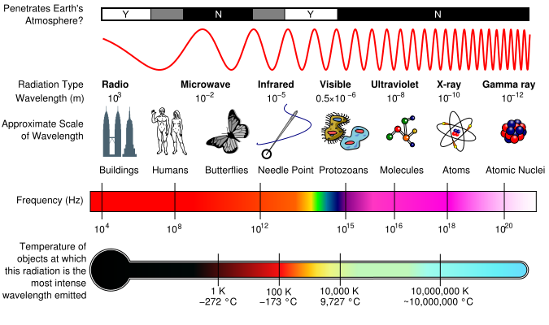

wave
- Young’s two-slit experiment demonstrated the _____________________ theory of light. This theory is known as classic physics.
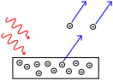
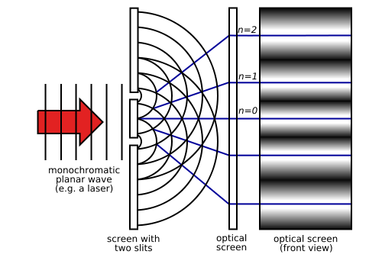

particle
- The photoelectric effect demonstrated the _______________ theory of light. These results are considered the foundation of quantum physics.
- What frequency of light is reflecting off the rocks? ______________
~430 nm
- What is the natural vibrating frequency of the electrons in the rocks? ________________
~430 nm
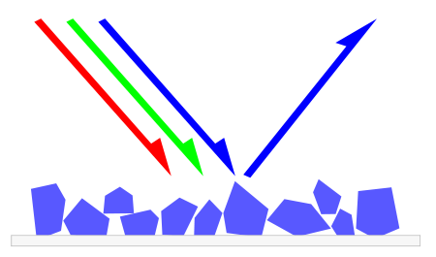
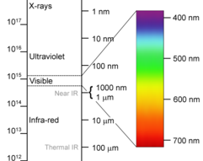


bent
- To the naked eye it looks as if this pencil is __________________,
which demonstrates what property of light? __________________
refraction

superposition
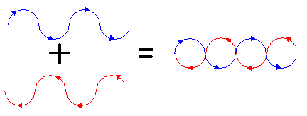
- The image below represents __________________ of the
red and blue waves.

- As the following two waves propagate towards one another, the result will be ______________________ interference.
constructive
