What is Biomedical Engineering

Biomedical engineers (also called bioengineers) use their knowledge of science and math to help solve health problems. Biomedical engineers develop materials, processes, and devices that help prevent or treat disease or rehabilitate patients. According to the Biomedical Engineering Society, the areas of specialization for biomedical engineers include biomaterials; bioinstrumentation; biomechanics; medical imaging; rehabilitation; and cellular, tissue, and genetic engineering.

Biomedical engineers who specialize in biomaterials develop materials that can be safely implanted in the body. Engineers who work in biomechanics apply principles from physics to biological systems. They develop artificial organs, such as the artificial heart. Engineers who focus on bioinstrumentation use computers or other electronic devices to diagnose or treat disease. A rehabilitation engineer helps improve the quality of life for people with disabilities. Tissue and cellular engineers grow cells outside of the body to be implanted in the body and serve some function. Genetic engineering is a related discipline in which an organism’s DNA is altered so that different proteins will be produced. Genetic engineering has many applications in drug production. For more information regarding the specialties within bioengineering, please see the “Introduction to Biomedical Engineering” worksheet below.

What are Material Properties?

The proper selection of materials is critical in all areas of engineering design. All materials have different properties that may or may not make them suitable for a given application. Materials come from natural resources. They are made up of the elements found on the periodic table. They may be elements in their pure form or a combination of elements. Materials are often processed to give them different properties. Some different types of materials include metals, plastics, composites, ceramics, and textiles. The properties of these materials are usually divided into three different categories: physical properties, mechanical properties, and chemical properties.

Physical properties include color, density, melting point, and water absorption rate. Mechanical properties include strength, ductility, and rigidity. Chemical properties include the composition of the material or the corrosion resistance of the material. To select the proper materials for an application, an engineer must first determine the properties that are important for his/her design. Once this determination has been made she/he can then research specific materials which may have the necessary properties.

For more information on materials see the handout “Material Properties” attached below.

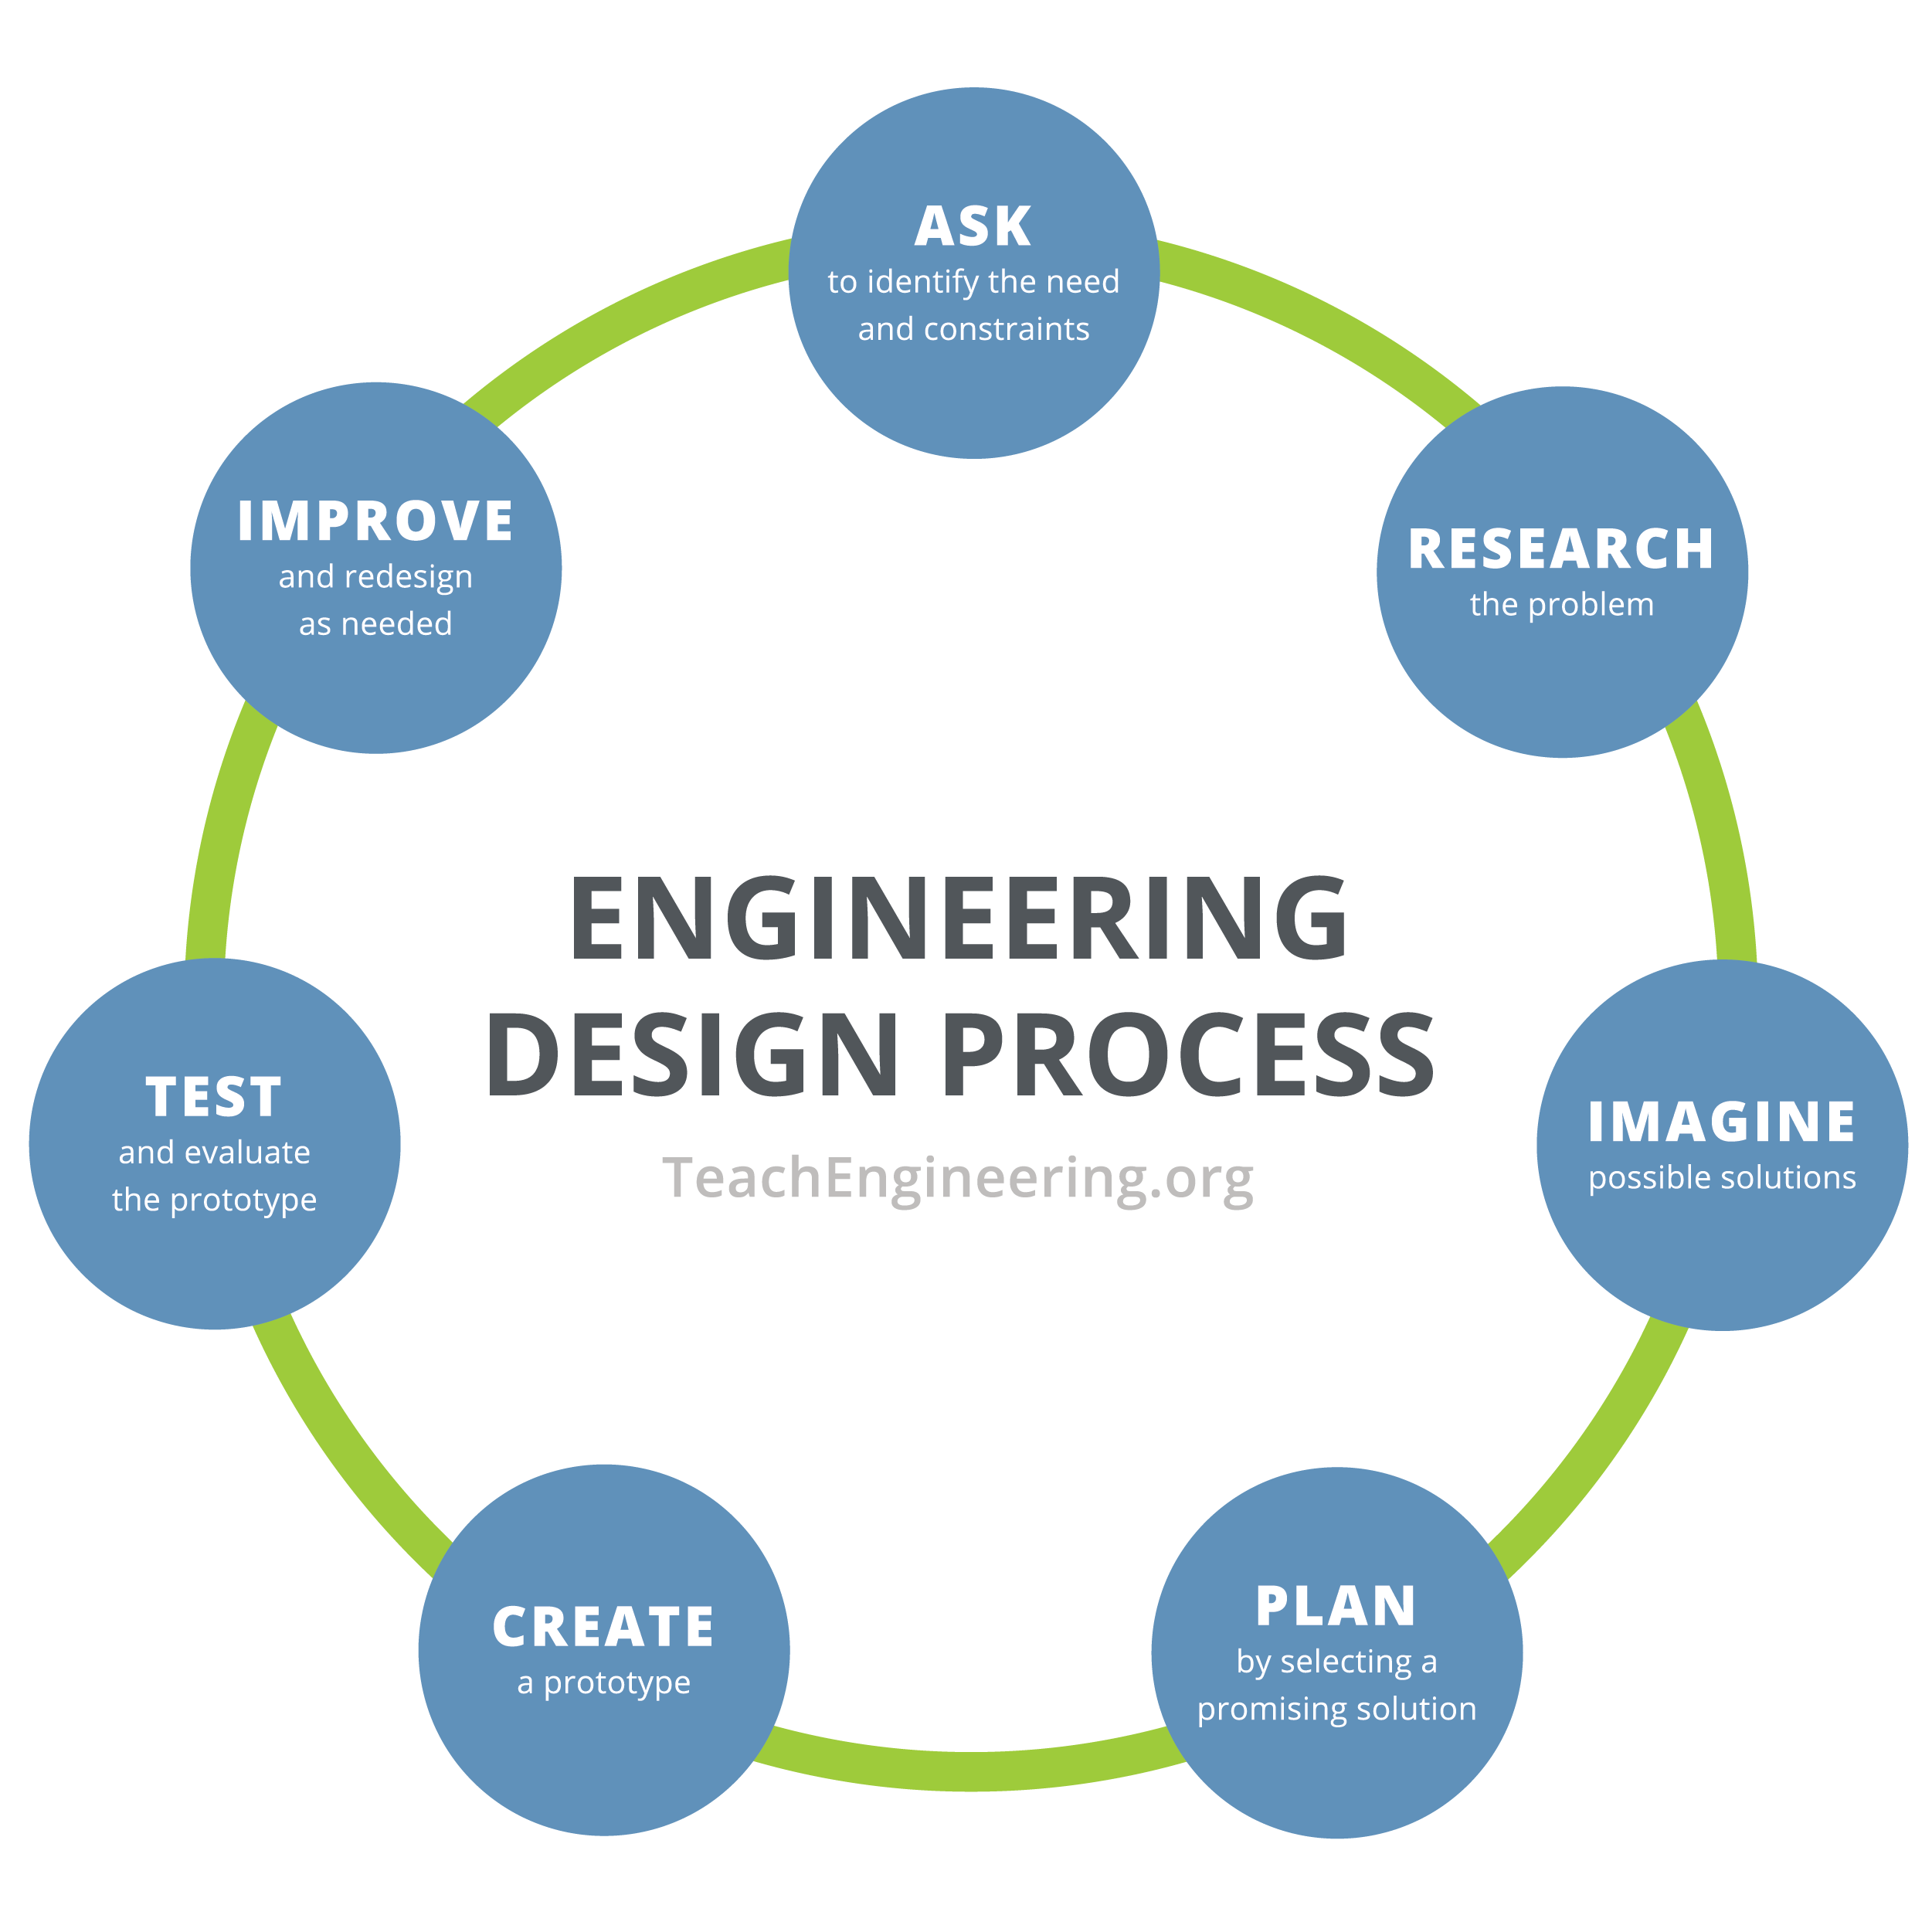
The Engineering Design Process

All engineers follow a series of problem-solving steps called the engineering design process. This process consists of the following seven steps:
1. Ask to identify the need or problem
2. Research the problem
3. Imagine possible solutions
4. Plan by selecting a promising solution
5. Create a prototype
6. Test and evaluate the prototype
7. Improve and redesign as needed
Pass out the “Engineering Design Process” handout. Explain to students that they will be redesigning a cast. Review the design process with students. Encourage them to relate this process to their project.

