Cast Design Student Worksheet

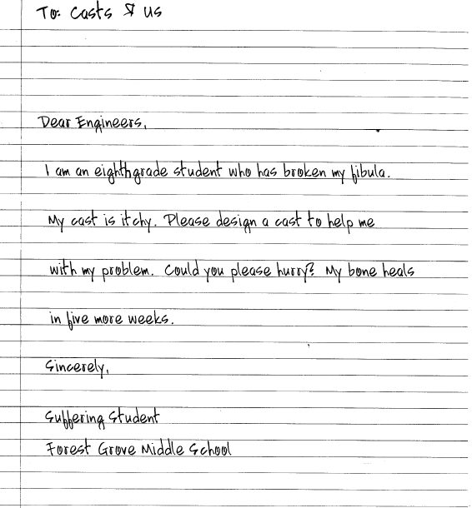

- What is the problem you are trying to solve?

- What materials does your box contain?

- What were the results of your brainstorming session? What are the possible solutions to your problem?

- What is the best solution for your problem? Describe your prototype?

- Draw a sketch of your prototype on the back of this page. Include a front, top, and side view?

Poster Session
Scientists and engineers often share their ideas with posters. You and your teammates will be designing a poster to explain your cast design to other members of your class. Include the following topics on your poster:

 The engineering design process.
 The problem your group was trying to solve.
 Any preliminary sketches you have made as well as your final design.
 A description of your prototype.
 A list of materials used.
 A description of what properties the materials have (e.g., weight, flexibility, or strength).
 Examples of how you evaluated your design to determine if it works.
 An analysis of whether the new design solves the original problem.
 A description of how you would improve your prototype if given time for a redesign.

