NAME: ________________________

CLICK PEN
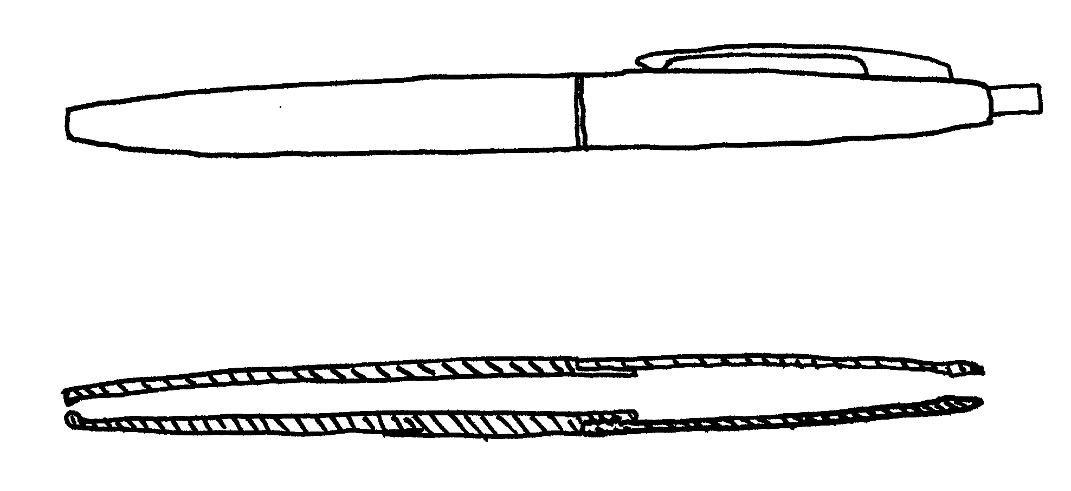
Ordinary View

Cross-sectional View

Parts

