Name__________________

Clic™ Pen Investigation

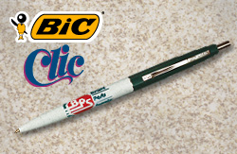
1. Look at this "Clic™ pen". How does this device work? Use words, labels, and drawings to explain your answer.

2. Why would someone invent a pen with a retractable ballpoint?

