Engineering Design Challenge Packet
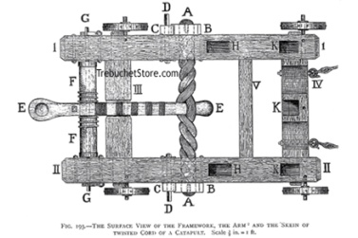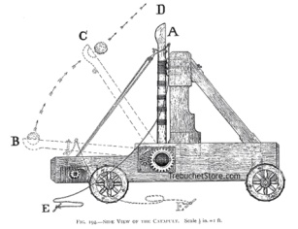
http://www.redstoneprojects.com/trebuchetstore/catapult_2.jpg
Client Statement
Create a “slinger” to be used in an indoor game. The slinger should be made entirely out of the materials provided. The slinger should launch a Ping-Pong ball approximately 20 f into a goal. The slinger should be able to be aimed by the players and be safe for use.

Problem Statement: _________________________________________________
___________________________________________________________________
___________________________________________________________________
___________________________________________________________________
___________________________________________________________________

Function: __________________________________________________________
___________________________________________________________________
___________________________________________________________________
___________________________________________________________________
___________________________________________________________________

Objective: __________________________________________________________
___________________________________________________________________
___________________________________________________________________
___________________________________________________________________
___________________________________________________________________
Constraints: ________________________________________________________
___________________________________________________________________
___________________________________________________________________
___________________________________________________________________
Design Solution (sketch your proposed solution):

Prototype: _________________________________________________________
___________________________________________________________________
___________________________________________________________________
___________________________________________________________________
___________________________________________________________________
Test Results
Trial | Way Off Target | Off Target | Close | Very Close | Edge of Net | Score
Example |  | X
1
2
3
4
5
6
7

Create a dot plot of your results from the table. What do you notice about your graph?

Evaluation of Results _________________________________________________
___________________________________________________________________
___________________________________________________________________
___________________________________________________________________
___________________________________________________________________

