Part 2 Cell Phone Activity Setup Sketch
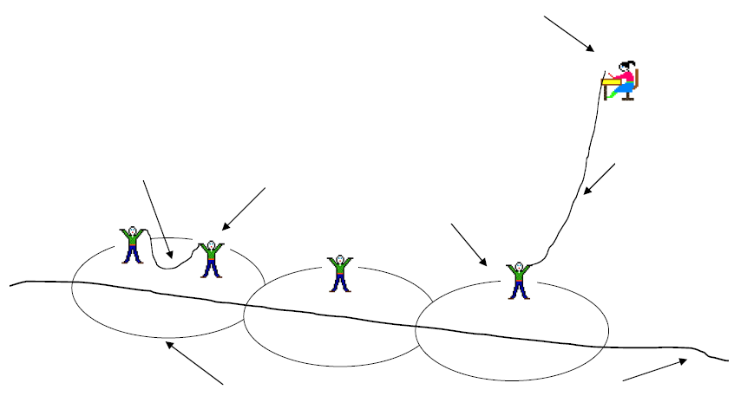
stationary caller
(landline)

yarn showing call connection; moves with driver location
moving driver with cell phone
yarn connecting land line to cell towers (does not move)

cell tower
(student)

winding road (made with tape)
transmission areas for towers (each marked with circle using
10-meter length of string)

