IMAGES OF SHADOW PLOT CONSTRUCTION

Set-Up:
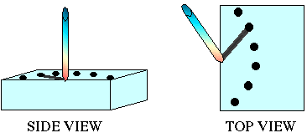

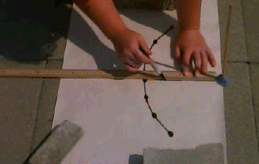
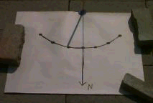
Drawing the North-South line:

IMAGES OF HORIZONTAL SUNDIAL CONSTRUCTION

Set-Up:

Hour Line Markings for 45° Latitude:
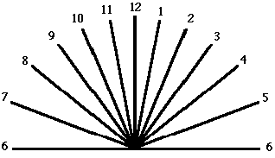

Aligning the wooden disk with the hour line markings:
