What Makes Up YOUR shoe?

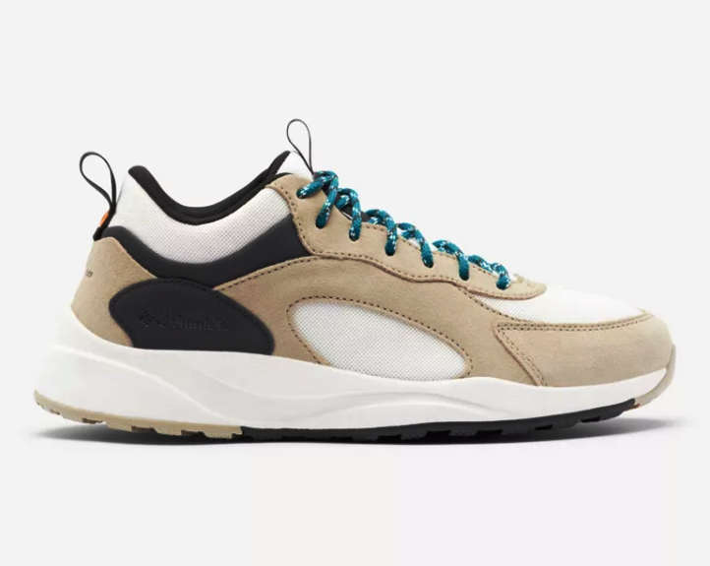
Inner sleeve provides breathability
Cushioning – insole & outsole
Visible Fabric web protects against
bruising

Outsole – aggressive traction lungs – for traction.
Interlocked mid-sole provides cushioning
“Mesh” material proved breathability and flexibility

