Space Shelter Research Handout
Name of planet: _________________________________________
Distance of planet from Earth: _____________ miles _____________ kilometers
Distance of planet from Sun: _____________ miles _____________ kilometers

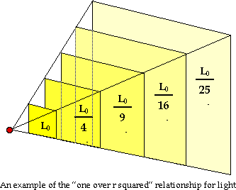
Brightness of Sun compared to Earth
Brightness of Sun compared to Earth =
__________________
A value of 2 above would mean sunshine on your planet is twice as bright as Earth’s! A value of 0.5 would be mean the sunshine is half as bright.

Day length: ______________________________ Earth-hours
Percentage of O₂ in atmosphere: ______________________________ % O₂
Strength of gravity: ______________________________ g
Climate: ________________________________________________________________
________________________________________________________________________
Surface composition: _____________________________________________________
________________________________________________________________________
Any other facts you need to know to survive: _________________________________
________________________________________________________________________
How will you get to the new planet from earth? _______________________________
________________________________________________________________________
What 5 things will you take with you and why? _______________________________
________________________________________________________________________

