Wristwatch for the Visually Impaired Activity –
Wristwatch Project Description
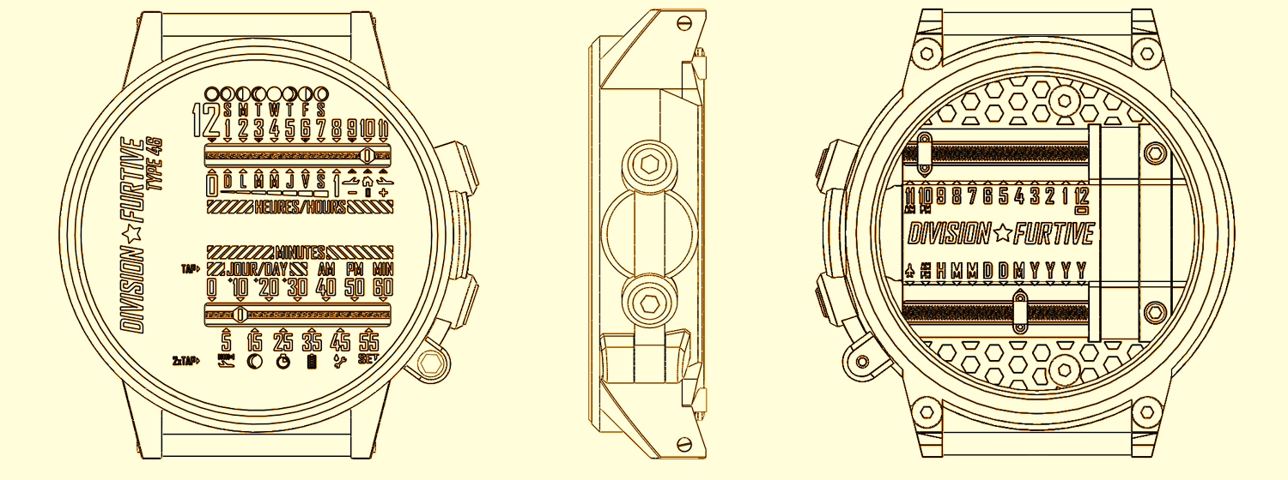

Client Statement
Time Incorporated, a leading watch manufacturing company in New England whose target audience is the young adult consumer (11-19-years old), has hired you, the engineers of Rising Star Academy. A recent development in the school of the owner’s children has given her the idea to develop a new wristwatch: a watch designed to help people with severe visual impairment. Your challenge is to develop a new wristwatch that fits the average 11-19-year old person, looks good, and is easy to understand. The number one goal of this product is to help young adults with visual impairment feel more independent.
Requirements
- Design a wristwatch for a visually impaired person.
- The wristwatch must be able to convey the time to the nearest 5 minutes without using the sense of sight.
- The wristwatch must be similar in size and shape to a traditional wristwatch and “look good” to wear.
Testing
Develop a 3-4 question survey to evaluate the effectiveness of your wristwatch design. The survey should evaluate the visual appeal of the wristwatch, the ease of understanding and at least one other focus area. Have five people evaluate your group’s wrist-watch design
Deliverables
- Three possible design solutions with a pros/cons T-chart for each design
- Multi-view drawings
- Classroom prototype
- Completed Engineering Design Process packet
- Design presentation (3-5 min.)

