Density & Miscibility Quiz
Definitions
- miscible
- immiscible
- hydrophobic
- hydrophilic
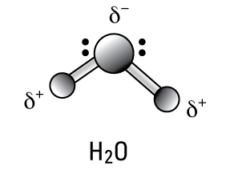
Draw a water molecule (stick model) below; label the charges on the atoms.

Circle True or False
Oil, water and corn syrup are miscible. T F
Ethanol and water are miscible. T F
A hydrogen bond is a force. T F
Oil and other carbon chains are hydrophilic. T F
Detergent is both hydrophobic and hydrophilic. T F
Questions
In an oil spill, what type of environmental clean-up could take advantage of the immiscibility between oil and water? Explain.

What type of oil spill clean-up method is similar to the role that the detergent played in the density column? Explain.

