Density & Miscibility Quiz Answers
Definitions
- miscible capable of mixing without separating into two phases
- immiscible incapable of mixing
- hydrophobic fear of water or “water-hating”
- hydrophilic “water-loving”
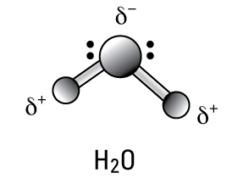
Draw a water molecule (stick model) below; label the charges on the atoms.

Circle True or False
Oil, water and corn syrup are miscible. T F
Ethanol and water are miscible. T F
A hydrogen bond is a force. T F
Oil and other carbon chains are hydrophilic. T F
Detergent is both hydrophobic and hydrophilic. T F
Questions
In an oil spill, what type of environmental clean-up could take advantage of the immiscibility between oil and water? Explain.
The use of booms takes advantage of the immiscibility between oil and water because booms are used to isolate the oil from the water. The fact that the oil and water are immiscible, or do not mix, allows for this isolation.
What type of oil spill clean-up method is similar to the role that the detergent played in the density column? Explain.
The detergent acted similar to chemical dispersants, because both detergent and dispersants allow two naturally immiscible liquids, oil and water, to mix together.

